SYSTEM CAPACITY & CARE LOAD ANALYTICS
Unaccompanied Children (UAC) Program
Executive Summary · Data Coverage: Jan 12, 2023 – Dec 21, 2025 · Prepared for HHS / Unified Mentor stakeholders

Purpose
HHS currently lacks a centralized way to continuously monitor total care-system load, the balance between inflow and outflow, and periods of capacity stress across the CBP-to-HHS unaccompanied children (UAC) pipeline. This summary presents the key findings from a full analysis of 720 days of daily operational data (2023–2025) and the resulting KPI framework and dashboard now available to support proactive, data-driven decisions.

Current System Snapshot
2,502  Latest Total Load  children under care, 12/21/2025 | -71%  2023→2025 Change  avg. total system load | 11,762  Peak Load  Dec 20, 2023 | 1.24%  Avg. Volatility  7-day rolling index | 1.28  Median Discharge Ratio  discharges ÷ transfers-in

Key Findings
- System load has declined sharply and sustainably. Average total system load (CBP custody + HHS care) fell from ~8,847 (2023) to ~2,576 (2025) — a ~71% reduction — driven primarily by lower CBP intake (117.6/day avg. in 2023 vs. 13.0/day in 2025), not solely faster HHS discharge.
- The sharpest relief window was Q1 2025. Monthly average total load dropped from ~5,080 (Jan 2025) to ~2,186 (Mar 2025) — a ~57% decline in two months — after which the system stabilized in a ~2,000–2,550 operating band.
- The most acute historical stress was late 2023–early 2024, with total load twice exceeding 11,000 and CBP custody spiking to 531 children in a single day (Feb 4, 2024) — CBP-side surges are the leading indicator of acute strain.
- Backlog accumulation is typically short-lived. Sustained positive net-intake streaks rarely exceed 4–5 consecutive days, indicating existing discharge/placement processes generally absorb normal week-to-week variation.
- Operational volatility has stayed comparatively stable (~1.2% avg.) even as absolute system size changed dramatically — a favorable signal for scalable staffing and shelter-capacity models.
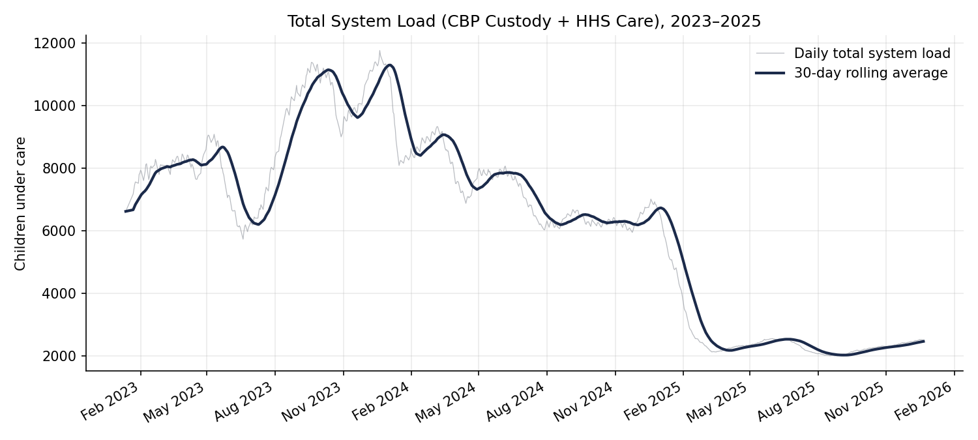
Total system load, 2023–2025, with 30-day rolling average. The Q1 2025 step-down and subsequent stable, lower-volume period are clearly visible.

Recommendations
- Adopt the five-KPI framework (Total Children Under Care, Net Intake Pressure, Care Load Volatility Index, Backlog Accumulation Rate, Discharge Offset Ratio) as a standing weekly capacity review.
- Use the accompanying Streamlit dashboard for continuous, self-service monitoring with date-range, granularity, and metric filtering.
- Set an early-warning threshold on Backlog Streak (e.g., flag any streak beyond 5 days, the historical maximum observed) and on Discharge Offset Ratio falling below 1.0 over a rolling window.
- Treat CBP custody spikes as a leading indicator to trigger HHS shelter/staffing readiness reviews ahead of downstream load increases.

Deliverables Provided
- Full research paper — detailed EDA, methodology, findings, and recommendations.
- Interactive Streamlit dashboard — live KPI cards, trend charts, and filterable data export.
- This executive summary — condensed briefing for policymakers and program leadership.

