Name: Jeese O M Flana
Reg No: 411625104021
Department: B.E CSE
Subject: Web Interface Unit 05
Batch : 04
Project 02 : Student Progress Card using React

Aim
To develop a Student Progress Card web application using React that displays subject-wise marks in tabular form, and dynamically calculates the total marks, percentage, and overall grade using JavaScript logic embedded in a functional component.

Procedure
Step 1: Creating the React Application
A React application is created using Vite. The progress card is built as a single reusable component, Progress.jsx, styled with a dedicated Progress.css file.
Step 2: Defining the Subject Data
An array of subject objects, each holding a subject name and marks, is defined inside the component. This array drives the entire marks table, so the table is generated from data rather than being hard-coded row by row.
Step 3: Calculating Total and Percentage
The Array.prototype.reduce() method is used to sum all subject marks into a total. The percentage is derived by dividing the total by the number of subjects.
Step 4: Determining the Overall Grade
An if-else if-else chain checks the percentage against grade boundaries (90, 80, 70, 60) and assigns an overall grade of A+, A, B, C, or D accordingly.
Step 5: Rendering the Marks Table
The subjects array is rendered using Array.prototype.map(), producing one table row per subject. Each row calculates its own per-subject grade inline using nested ternary conditional rendering, and displays a PASS status.
Step 6: Displaying the Summary Section
A summary section shows the total marks, percentage, overall grade, and final result (PASS) in a four-column grid layout, computed from the values derived in earlier steps.
Step 7: Adding College Header, Student Details, and Footer
Static sections for the college name and department, the student's name and register number, and a footer with signature lines for the Class Teacher and Principal complete the printable progress card layout.
Step 8: Applying Styling and Responsive Design
CSS is used to style the header, table, and summary grid. A media query at 700px switches the student details to a stacked layout, reduces table padding and font size, and adjusts the summary grid to two columns for smaller screens.
Step 9: Testing the Application
The application is executed using the Vite development server. The app is tested by checking:
- Correct rendering of all subject rows from the data array
- Accuracy of the total, percentage, and grade calculations
- Per-subject grade logic against the marks table
- Responsive layout on smaller screen widths

React Concepts Used
- Functional Components
- JSX
- Array Methods (reduce, map)
- Conditional Rendering (if-else, ternary operator)
- Component-Based Architecture
- CSS Styling
- Responsive Web Design (media queries)

Code
Progress.jsx
import React from "react";
import "./Progress.css";

function Progress() {
const subjects = [
{ name: "Web Interface", marks: 85 },
{ name: "Data Structures", marks: 78 },
{ name: "Database Management", marks: 82 },
{ name: "Java Programming", marks: 88 },
{ name: "Computer Networks", marks: 75 },
];
const total = subjects.reduce((sum, subject) => sum + subject.marks, 0);
const percentage = total / subjects.length;

let grade = "";

if (percentage >= 90) {
grade = "A+";
} else if (percentage >= 80) {
grade = "A";
} else if (percentage >= 70) {
grade = "B";
} else if (percentage >= 60) {
grade = "C";
} else {
grade = "D";
}

return (
<div className="progress-page">
<div className="progress-card">

{/* College Header */}
<div className="college-header">
<h1>PRINCE DR. K. VASUDEVAN COLLEGE OF ENGINEERING AND TECHNOLOGY</h1>
<p>Department of Cyber Security</p>
<h2>STUDENT PROGRESS CARD</h2>
</div>

{/* Student Details */}
<div className="student-details">
<div>
<p><b>Name:</b>Flana </p>
<p><b>Register No:</b> 411625104021</p>
</div>
<div>
<p><b>Department:</b> B.E.</p>
<p><b>Semester:</b> III</p>
</div>
</div>
{/* Marks Table */}
<table>
<thead>
<tr>
<th>S.No</th>
<th>Subject</th>
<th>Marks</th>
<th>Grade</th>
<th>Result</th>
</tr>
</thead>
<tbody>
{subjects.map((subject, index) => (
<tr key={index}>
<td>{index + 1}</td>
<td>{subject.name}</td>
<td>{subject.marks}</td>
<td>
{subject.marks >= 90
? "A+"
: subject.marks >= 80
? "A"
: subject.marks >= 70
? "B"
: subject.marks >= 60
? "C"
: "D"}
</td>
<td className="pass">PASS</td>
</tr>
))}
</tbody>
</table>

{/* Summary */}
<div className="summary">
<div>
<span>Total Marks</span>
<b>{total} / {subjects.length * 100}</b>
</div>
<div>
<span>Percentage</span>
<b>{percentage.toFixed(2)}%</b>
</div>
<div>
<span>Overall Grade</span>
<b>{grade}</b>
</div>
<div>
<span>Result</span>
<b className="overall-pass">PASS</b>
</div>
</div>
{/* Footer */}
<div className="card-footer">
<p><b>Class Teacher</b></p>
<p><b>Principal</b></p>
</div>

</div>
</div>
);
}
export default Progress;

Progress.css
* {
box-sizing: border-box;
}
body {
margin: 0;
font-family: "Segoe UI", sans-serif;
background: linear-gradient(135deg, #667eea, #764ba2);
}

/* MAIN PAGE */
.progress-page {
min-height: 100vh;
padding: 40px 20px;
display: flex;
justify-content: center;
align-items: center;
}
/* CARD */
.progress-card {
width: 900px;
padding: 35px;
background: #ffffff;
border-radius: 20px;
box-shadow: 0 15px 40px rgba(0, 0, 0, 0.2);
}
/* COLLEGE HEADER */
.college-header {
text-align: center;
padding-bottom: 20px;
border-bottom: 1px solid #ddd;
}
.college-header h1 {
margin: 5px 0;
font-size: 24px;
color: #4c3f91;
}
.college-header p {
margin: 8px 0;
color: #777;
}
.college-header h2 {
margin-top: 15px;
color: #222;
}
/* STUDENT DETAILS */
.student-details {
display: grid;
grid-template-columns: 1fr 1fr;
gap: 10px 40px;
padding: 25px 10px;
}
.student-details p {
margin: 8px 0;
color: #444;
}
/* TABLE */
table {
width: 100%;
border-collapse: separate;
border-spacing: 0;
margin-top: 10px;
overflow: hidden;
border-radius: 10px;
}

th,
td {
padding: 14px;
text-align: center;
border-bottom: 1px solid #ddd;
}
th {
background: #4c3f91;
color: white;
font-weight: 600;
}
td {
background: #faf9ff;
}
td:nth-child(2) {
text-align: left;
}
tr:hover td {
background: #f0edff;
}
.pass {
color: #219653;
font-weight: bold;
}
/* SUMMARY */
.summary {
display: grid;
grid-template-columns: repeat(4, 1fr);
gap: 15px;
margin-top: 30px;
}
.summary div {
padding: 20px 10px;
text-align: center;
background: #f4f1ff;
border-radius: 12px;
border: 1px solid #e2dcff;
}
.summary span {
display: block;
font-size: 13px;
color: #777;
margin-bottom: 10px;
}

.summary b {
font-size: 20px;
color: #4c3f91;
}
/* RESULT */
.overall-pass {
color: #219653;
font-weight: bold;
}
/* FOOTER */
.card-footer {
display: flex;
justify-content: space-between;
margin-top: 60px;
padding: 0 20px;
}
.card-footer p {
min-width: 150px;
text-align: center;
padding-top: 10px;
border-top: 2px solid #aaa;
color: #555;
}

/* MOBILE */
@media (max-width: 700px) {
.progress-page {
padding: 15px;
}
.progress-card {
width: 100%;
padding: 20px;
}
.college-header h1 {
font-size: 18px;
}
.student-details {
grid-template-columns: 1fr;
}
table {
font-size: 12px;
}
th,
td {
padding: 9px;
}
.summary {
grid-template-columns: 1fr 1fr;
}
.card-footer {
padding: 0;
margin-top: 40px;
gap: 15px;
}
.card-footer p {
min-width: 100px;
font-size: 12px;
}
}
App.jsx
import React from "react";
import Progress from "./Progress.jsx";
function App() {
return (
<Progress />
);
}
export default App;

Output
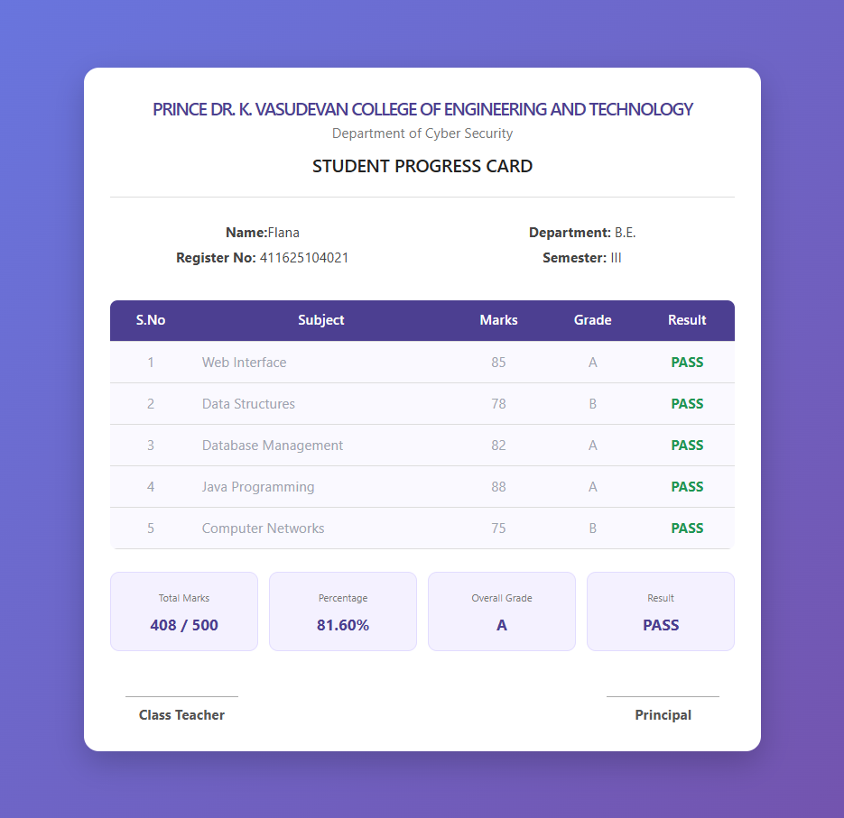

Result
The Student Progress Card application was successfully developed using React. The project demonstrates data-driven rendering with array methods, conditional grade logic, component-based architecture, and responsive CSS styling.

