Algorithm_hw3

21500706 지성민

* **Problem 1 :**

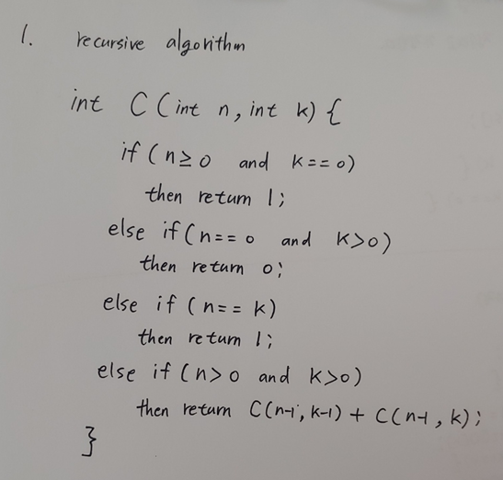

* **Problem 2 :**

