Interactive Data Visualization with Bokeh
Python Bokeh is a Data Visualization library that provides interactive charts and plots. Unlike Matplotlib and Seaborn, Bokeh renders its plots using HTML and JavaScript. It targets modern web browsers for presentation providing elegant, concise construction of novel graphics with high-performance interactivity.

Python Bokeh is a Data Visualization library that provides interactive charts and plots. Bokeh renders its plots using HTML and JavaScript that uses modern web browsers for presenting elegant, concise construction of novel graphics with high-level interactivity.

Features of Bokeh:
- Flexibility: Bokeh can be used for common plotting requirements and for custom and complex use-cases.
- Productivity: Its interaction with other popular Pydata tools (such as Pandas and Jupyter notebook) is very easy.
- Interactivity: It creates interactive plots that change with the user interaction.
- Powerful: Generation of visualizations for specialized use-cases can be done by adding JavaScript.
- Shareable: Visual data are shareable. They can also be rendered in Jupyter notebooks.
- Open source: Bokeh is an open-source project.

Interface Level:Bokeh supports different interface levels can be used by users:
- a low-level:bokeh.models interface provides the most flexibility to application developers.
- an intermediate-level:bokeh.plotting interface is composing of all visual glyphs.
- a high-level:bokeh.charts interface is used to build complex plots easily.

Installation
To install the bokeh library, we can use the following command:
pip install bokeh
Required Dependencies

- bokeh==2.4.3
- Jinja2==3.1.2
- MarkupSafe==2.1.1
- numpy==1.23.2
- packaging==21.3
- Pillow==9.2.0
- pyparsing==3.0.9
- PyYAML==6.0
- tornado==6.2
- typing_extensions==4.3.0

- Example program: simple_plot.py
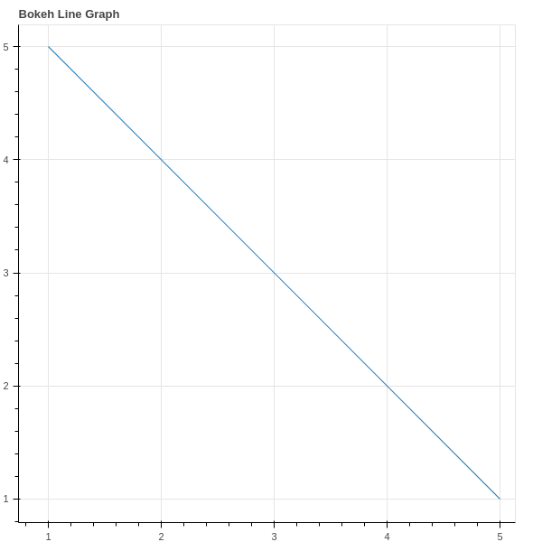

Bokeh – Annotations and Legends
Bokeh includes several types of annotations to allow users to add supplemental information to their visualizations. Annotations can be titles, legends, Arrows, bands, labels etc.
Adding legends figures will helps to describe and define it properly. Legends in Bokeh are simple to implement. They can be basic, automatically grouped, manually mentioned, explicitly indexed and also interactive.

- Example program: annotations_legends.py
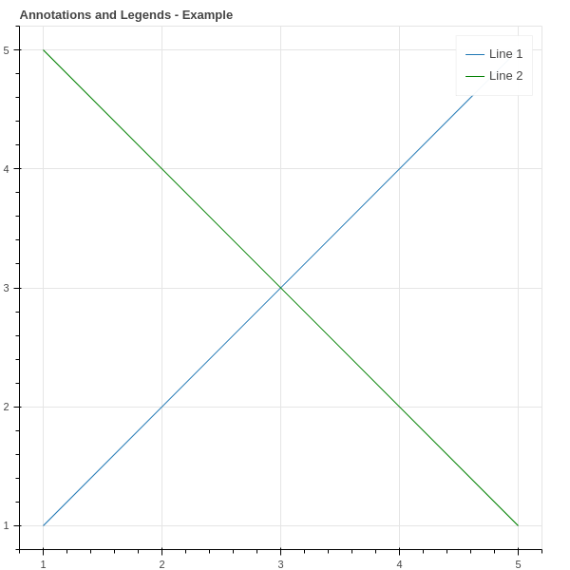

- Example program: automatically_grouped.py
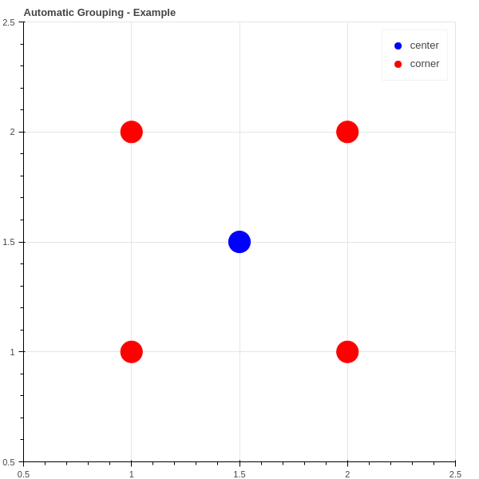

Customizing Legends
Legends in Bokeh can be customized using the following properties.
Property | Description
legend.label_text_font | change default label font to specified font name
legend.label_text_font_size | font size in points
legend.location | set the label at specified location.
legend.title | set title for legend label
legend.orientation | set to horizontal (default) or vertical
legend.clicking_policy | specify what should happen when legend is clicked

