|  |  |  |  |
| --- | --- | --- | --- |
| **S. No.** | **Topic** | **Date** | **Remark** |
|  | Write a program to DFA that accept string.   1. baab 2. abba | February 16, 2025 |  |
|  | 2.1. Write a program to check valid identifier.  2.2. Write a program to check valid comment or not. | February 16, 2025 |  |
|  | Write a program to count number of operators used in given input.  a=b+c*d | February 16, 2025 |  |
|  | 3.1. Write a program to find the first of given grammar.  S→L+R  S→R  L→*R  L→a  R→L  3.2. Write a program to find the follow of the given grammar.  R→aS  R→(R)S  S→+RS  S→aRS  S→aS | February 16, 2025 |  |
|  | Write a program for construction of LL(1) Parser. | February 16, 2025 |  |
|  | Write a program to implement shift reduce parsing.  E→E+E  E→E/E  E→E*E  E→a/b  Input symbol a+b+a | February 16, 2025 |  |
|  | Write a program to implement intermediate code generation.  X=a+b-c*d/e | February 16, 2025 |  |
|  | Write a program to implement machine code generation. | February 16, 2025 |  |

**Table of Content**





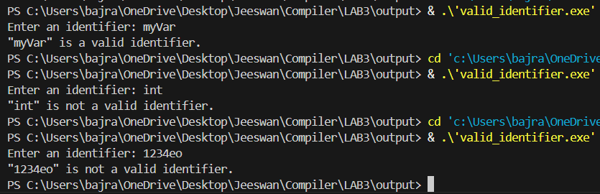

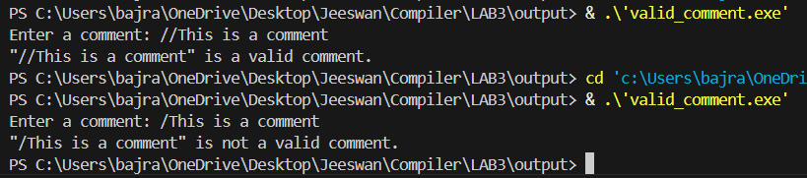

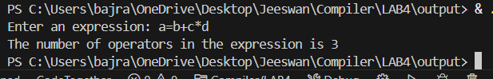

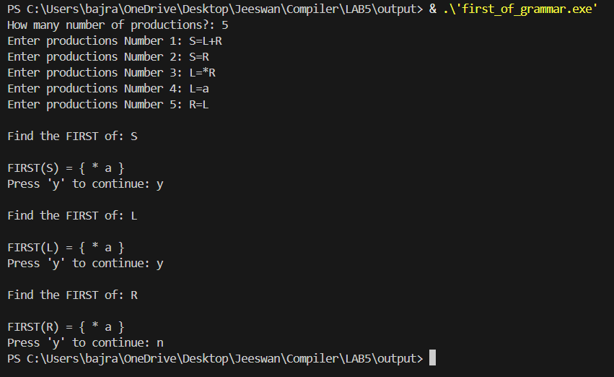

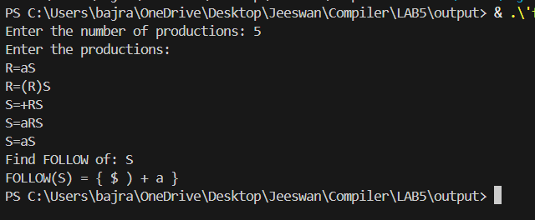

Output:

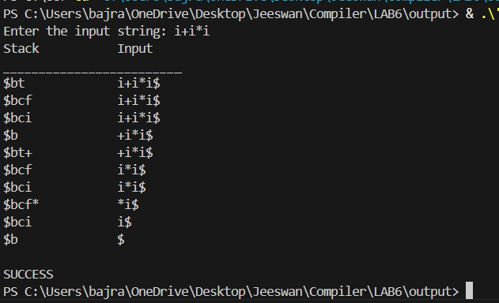

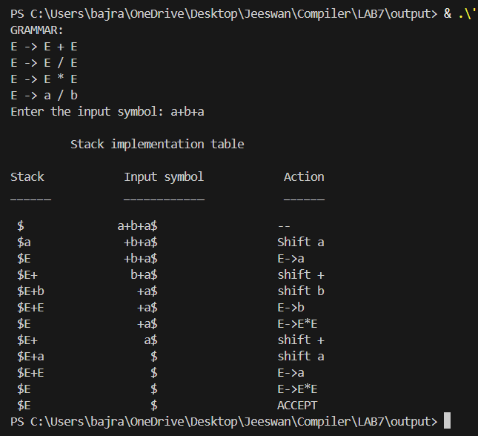

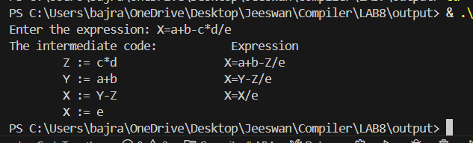

Output:

