Univariate Forecasting Models — Complete Architecture
Gradio Tab 3. Univariate Analysis: Holt-Winters, SARIMA, CNN-LSTM, Transformer, and N-BEATS on claims-only features. Companion markdown: docs/UNIVARIATE_MODEL_ARCHITECTURE.md.

1. Univariate Analysis tab — models and architecture
Tab 3 is claims-only. It does not use production, odometer, FCO/K intensity, or other Tab 1 EXOG_COLS, and it does not train via runner.py. Source: forecasting/pipeline/univariate.py and dashboard/univariate_views.py.
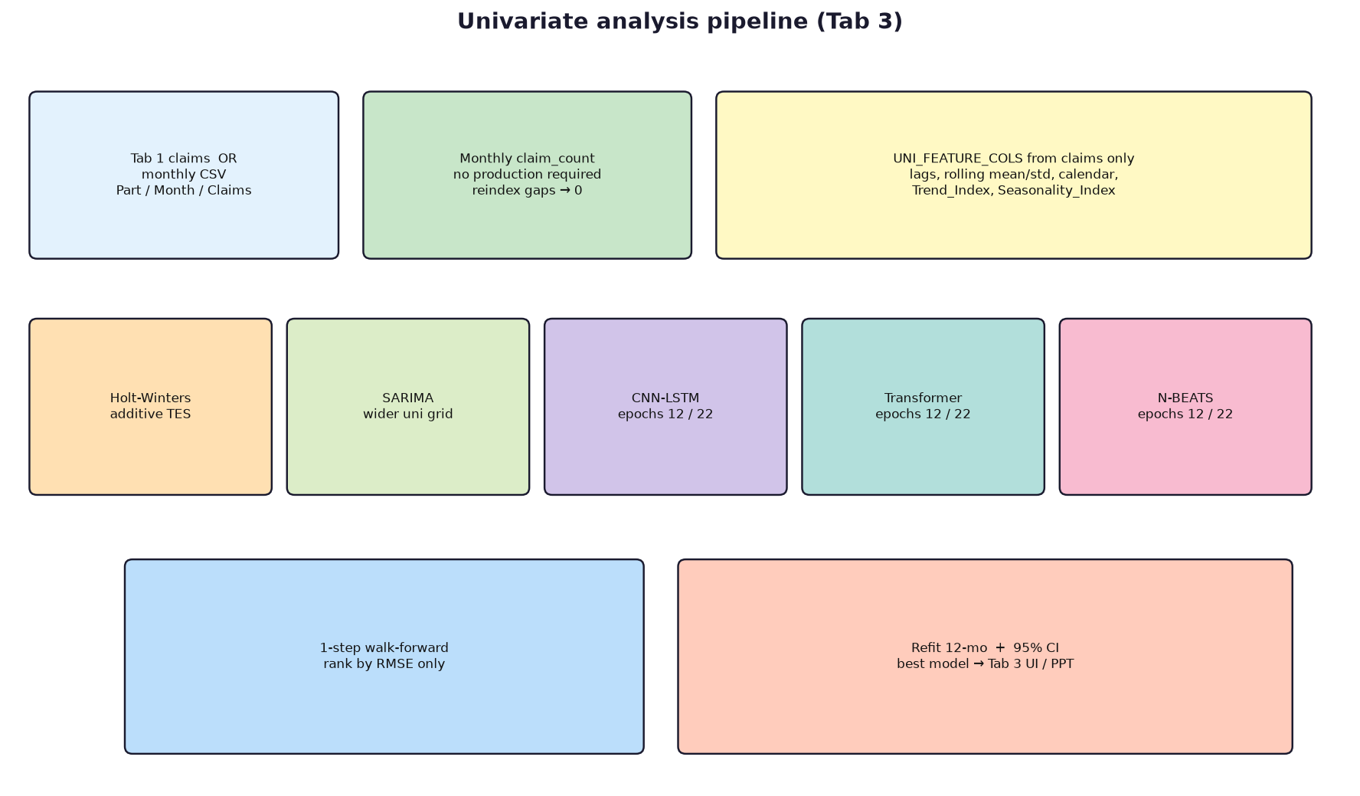
Model | Type | Tab 3 role
Holt-Winters | Additive exponential smoothing | Unique to Tab 3; level + trend + optional season
SARIMA | Seasonal ARIMA | Wider order grid than Tab 1; unscaled claims
CNN-LSTM | Same NumPy net as Tab 1 | UNI features; 12 CV / 22 refit epochs
Transformer | Same NumPy net as Tab 1 | Same wiring as CNN-LSTM
N-BEATS | Same NumPy net as Tab 1 | Same wiring as CNN-LSTM

Selection: one checkbox → that model. Several → lowest walk-forward RMSE (not the Tab 1 composite rank). No inverse-MAE ensemble, no Keras path, no CM multipliers.

1.1 Input, features, fusion
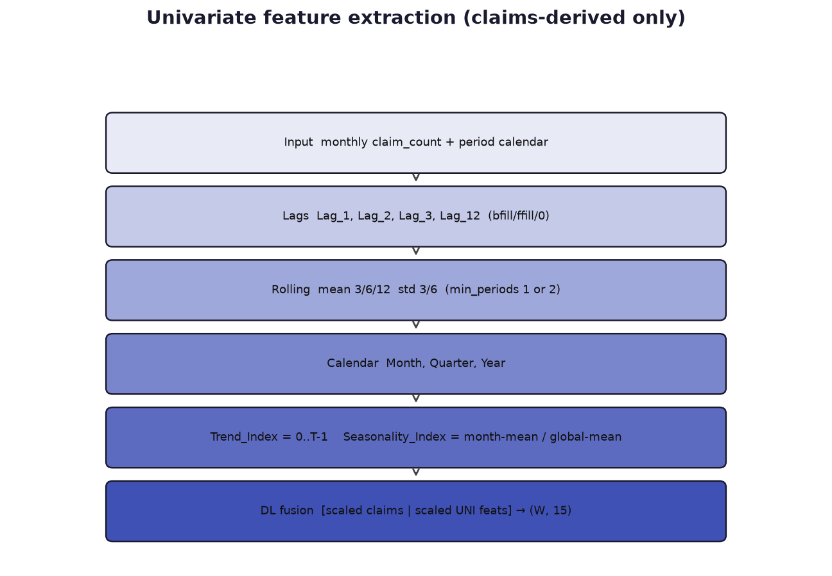
Inputs: Tab 1 claims (production not required) or a monthly CSV (Part Name, Month, Claims). Need at least 10 months and positive total claims. UNI_FEATURE_COLS: Lag 1/2/3/12, rolling mean 3/6/12, rolling std 3/6, Month/Quarter/Year, Trend_Index, Seasonality_Index (month-mean / global-mean). DL windows concatenate scaled claims with these 14 columns (F about 15). Lookback W = min(12, max(4, T//3)). Holt-Winters and SARIMA ignore UNI features.

1.2 Holt-Winters — layer breakdown
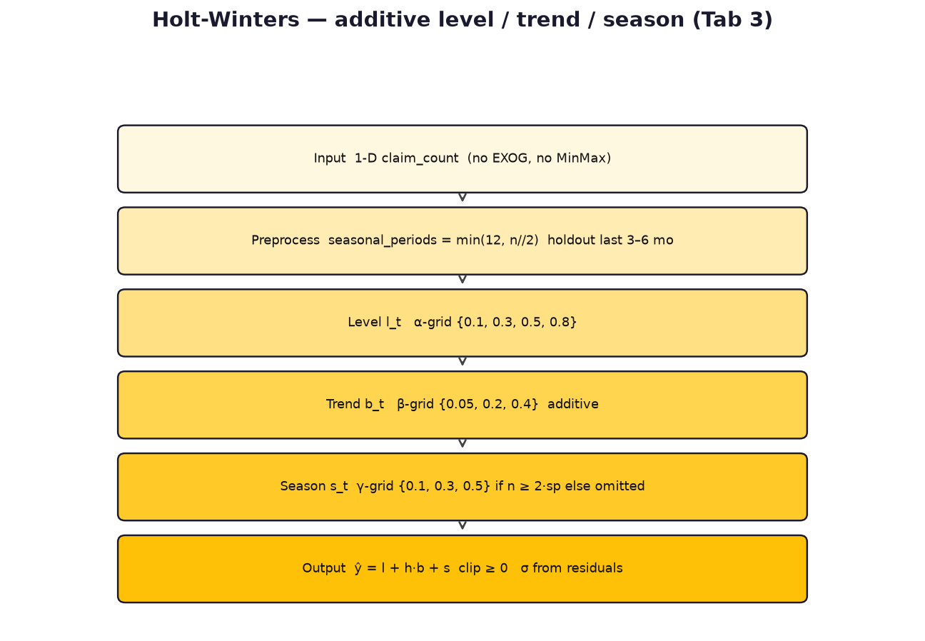
Stage | What happens | Params
Input | 1-D claim_count | No MinMax
Preprocess | sp = min(12, n//2); seasonal only if n >= 2*sp | holdout 3-6 months
Level | Additive TES level | alpha in {0.1, 0.3, 0.5, 0.8}
Trend | Additive slope | beta in {0.05, 0.2, 0.4}
Season | Additive yearly or omitted | gamma in {0.1, 0.3, 0.5}
Fit | ExponentialSmoothing estimated init, optimized=False | statsmodels
Output | forecast(H) clip >= 0; residual sigma for CI | Fail -> last value

l_t = a (y_t - s_{t-m}) + (1-a)(l_{t-1} + b_{t-1})
b_t = b (l_t - l_{t-1}) + (1-b) b_{t-1}
s_t = g (y_t - l_{t-1} - b_{t-1}) + (1-g) s_{t-m}
yhat_{t+h} = l_t + h b_t + seasonal_lag
Grid a x b x g on holdout RMSE, then refit on full y.
Unique extras: holdout RMSE grid; sigma feeds 95% CI; alpha/beta/gamma shown in accordion 3; no dropout/attention.

1.3 Univariate SARIMA
Same SARIMAX engine as Tab 1 (fit_sarima) on unscaled claims. Orders: (1,1,1), (1,1,0), (0,1,1), (2,1,1). Seasonal: (1,1,0,12), (0,1,1,12), (1,0,1,12). Pick lowest RMSE on a tail split; fallback seasonal-naive/mean. Orders printed beside Holt-Winters on Tab 3.

1.4 CNN-LSTM, Transformer, N-BEATS on Tab 3
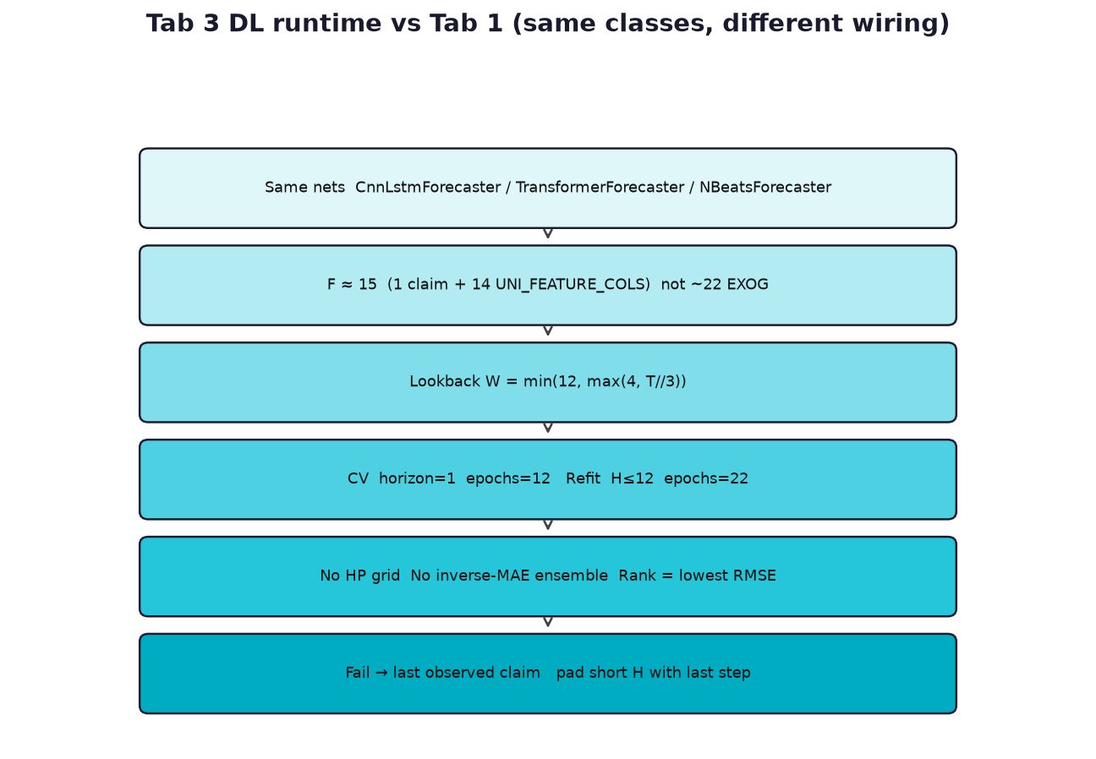
Layer stacks are identical to Tab 1 (CNN 16->8 + LSTM-32; Transformer MHA+FFN; N-BEATS 6 polynomial blocks). Differences are wiring: UNI features, epochs 12 (CV) and 22 (refit), no HP grid, fail -> last claim, short H padded with last step, rank by RMSE only. See multivariate sections 3-5 for gate/attention/basis detail.
CV: ctor(..., horizon=1, epochs=12)
Refit: ctor(..., horizon=H, epochs=22)
W = min(12, max(4, T//3))
CI: best +/- 1.96 * max(0.35*std(last12), 0.5*HW_sigma, 1)

1.5 Tab 3 UI outputs
Control | Meaning
Monthly CSV | Does not change Tab 1; Part Name / Month / Claims
Model checkboxes | Empty -> all five UNI_MODELS
1. Overview | Records, date span, missing months, quality status
2. Trend | Claims + rolling 3/12; seasonality bars; growth/6-mo %
3. Results | RMSE/MAE/MAPE rank + star; HW params; SARIMA orders
4. Forecast | Best solid line, others dotted, 95% CI, 12-row table
5. Insights | Trend/season/volatility/best RMSE/quality notes
Tab 6 PPT | Univariate slides only if Tab 3 has been run

1.6 Univariate edge cases
Case | Expected
No data | Prompt to load Tab 1 or CSV
< 10 months or zero claims | Run returns None
Gaps in months | Filled with 0; status Gaps filled
Short series for HW season | seasonal=None; gamma unused
DL too few windows | Naive last claim
One model checked | That model is best
Empty checkboxes | All five models
Winner vs Tab 1 | Often different — do not mix rankings

