Multivariate Forecasting Models — Complete Architecture
Automotive Warranty Claims Forecasting System. This document describes every multivariate model used in the project: NumPy CNN-LSTM, N-BEATS, Transformer, SARIMA, the inverse-MAE ensemble, and the optional Keras CNN-LSTM used on the annotated walk-forward tab. Source of truth: forecasting/models/*.py, forecasting/pipeline/runner.py, forecasting/data/loader.py, forecasting/dashboard/app_ui.py.
Generated to match the implementation (not a generic textbook architecture).

1. Scope and model roster
Multivariate here means the Tab 1 pipeline that forecasts claim counts from a lookback window that concatenates the target series with exogenous drivers (production, odometer, vehicle age, FCO/K batch intensity, Fourier seasonality, calendar, lags). SARIMA is trained on the claim series only but is scored in the same multivariate pipeline.
Model | Implementation | Purpose | Primary code
CNN-LSTM | Pure NumPy | Local patterns (CNN) + temporal memory (LSTM) | models/cnn_lstm.py
N-BEATS | Pure NumPy | Interpretable basis expansion with residual stacks | models/nbeats.py
Transformer | Pure NumPy | Long-range dependencies via self-attention | models/transformer.py
SARIMA | statsmodels | Classical seasonal baseline | models/ml_models.py
Ensemble | Pipeline | Inverse-MAE blend of selected models | pipeline/runner.py
Keras-CNN-LSTM | TensorFlow optional | Reference annotated last-6-month test | pipeline/annotated_forecast.py

Not used in this project: XGBoost, LightGBM, Gradient Boosting. Tree ML is excluded from MODEL_NAMES in forecasting/config.py.

2. Shared data flow and integration points
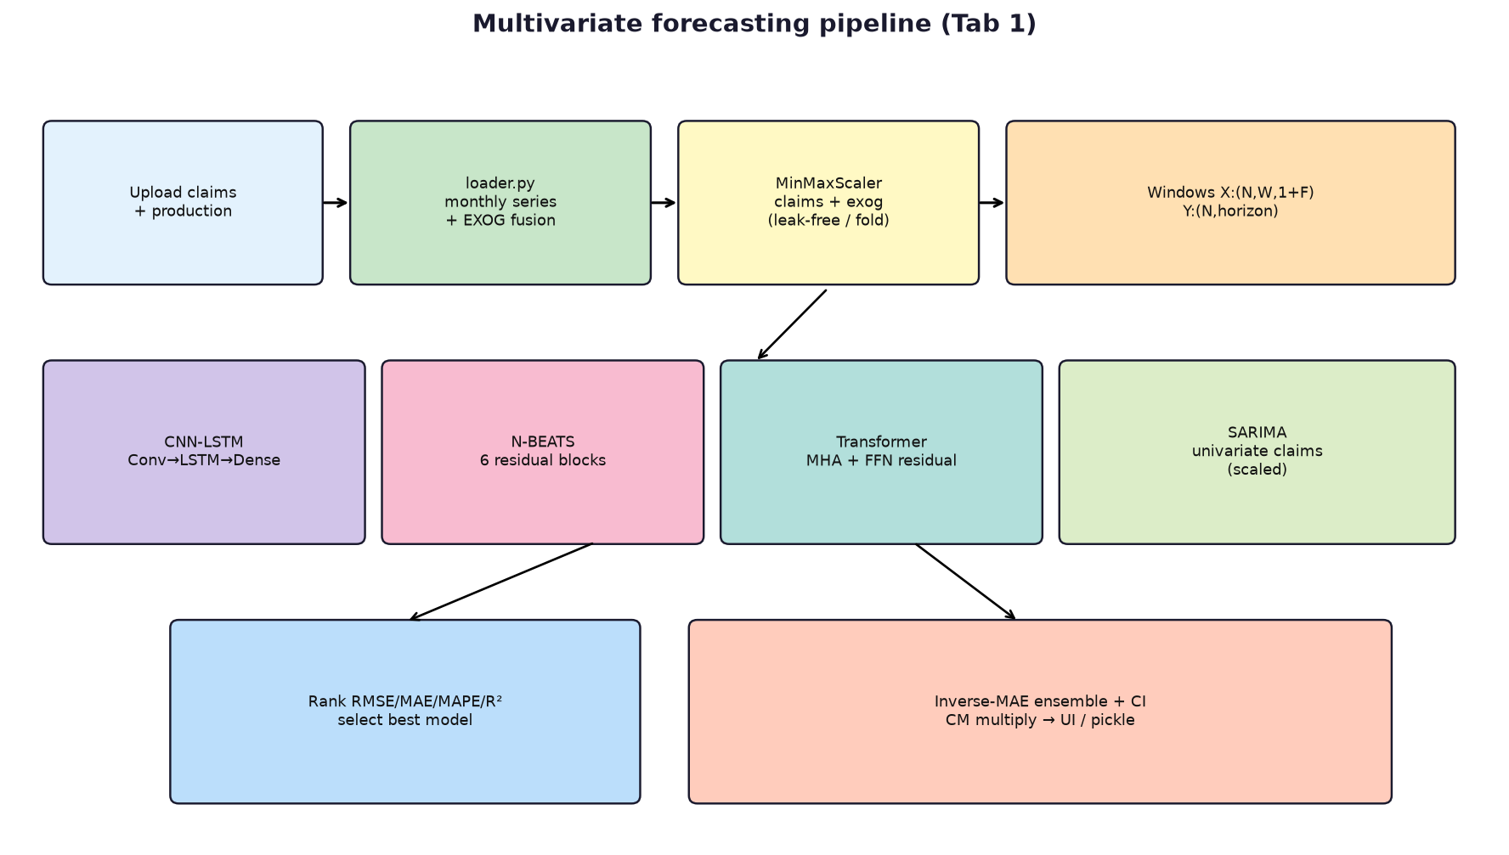

2.1 Input layer (data, not the neural net)
Claims rows are validated and normalised (Part Name, FCOK_DATE, PROCESSING_DATE, ODOMETER). Aggregation is by process month. Production is user-supplied (synthetic production is disabled for training). Gaps in the monthly calendar are reindexed and filled.

2.2 Preprocessing and feature extraction (fusion)
EXOG_COLS fused with scaled claims at each time step:
avg_odometer, avg_vehicle_age, avg_mfctr_age, production,
sin_12, cos_12, sin_6, cos_6,
median_odometer, max_odometer, median_vehicle_age,
n_fcok_batches, warranty_share, Vehicle_Age,
Month, Year, Quarter,
Claim_Lag_1, Claim_Lag_2, Claim_Lag_3, Claim_Lag_12
Window builder (runner.build_window_dataset): for each start index i, X[i] = concat(claim_window, exog_window) along the feature axis; y[i] = next `horizon` claim values. Shape X: (N, W, 1+F), y: (N, H). Walk-forward CV uses horizon=1; final refit uses FORECAST_HORIZON=12.

2.3 Normalization
Two MinMaxScalers: claims and exogenous matrix. Each CV fold fits scalers only on [:train_end] (no leakage). Inverse transform clips scaled values to [0, 1] then clips claims to ≥ 0. Full-history refit fits scalers on all months before the 12-month forecast.

2.4 Shared DL training utilities (base.py)
Activations: ReLU, numerically stable sigmoid, clipped tanh. Adam (Kingma & Ba) per-parameter keys. Inverted dropout (scale 1/(1-p) at train). EarlyStopTracker restores best weights after patience=5 epochs with no loss drop. RANDOM_SEED=42.
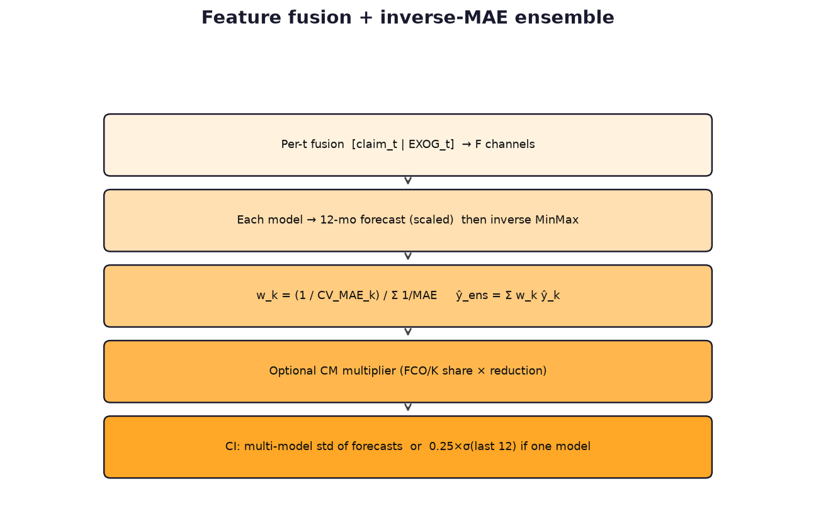

2.5 Ranking, best model, ensemble, CI, countermeasure
Metrics on walk-forward OOS actuals: RMSE 0.30, MAE 0.25, MAPE 0.25, R² 0.20 (min-max normalised costs). Best model is auto-selected when multiple models are checked; a single checked model is used as-is. Ensemble weights are inverse of mean CV MAE. Config-file CM multiplies the forecast by a decay curve; Tab 1 optional CM and Tab 4 FCO/K simulator adjust post-model outputs. CI: if one model, 1.5 × 0.25×std(last 12 claims); if several, 1.5 × std of model forecasts across months.

2.6 Persistence integration
outputs/models/*.pkl (scalers + DL objects + weights), outputs/forecasts/*.csv, outputs/best_params.json (locked HP per part). CNN-LSTM HP is never grid-searched (fixed lr=1e-2, epochs=40).

3. CNN-LSTM
Purpose: extract short local motifs in the multivariate window with 1-D convolutions, then model sequential dependence with an LSTM, and emit a multi-step claim forecast.
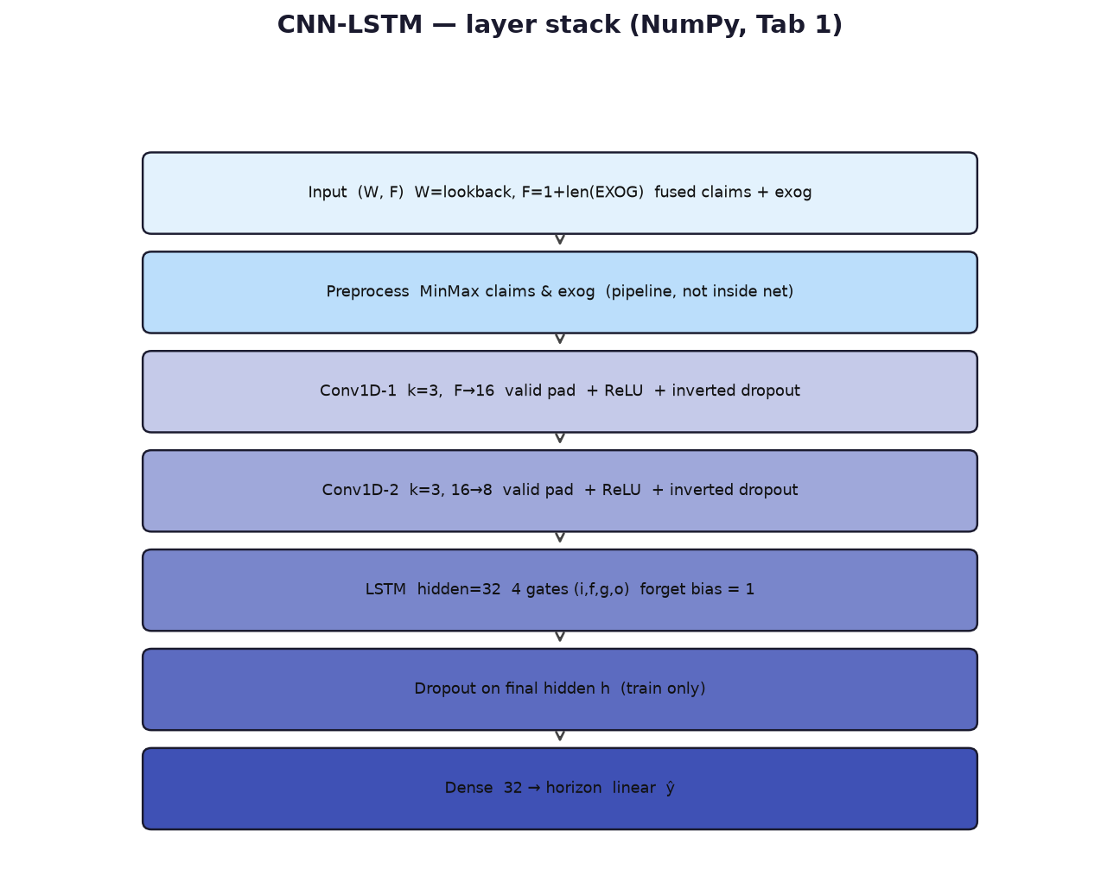

3.1 Layer-by-layer
Stage | What happens | Shapes / params
Input | One sample window of fused features | (W, F); default W=12
Preprocess | Leak-free MinMax in runner | F = 1 + n_exog (~21)
Conv1 | Valid 1-D conv, kernel 3, 16 filters, ReLU | (W,F)→(W-2, 16); Wc1 (3,F,16)
Dropout | Inverted dropout rate 0.2 if training | same as Conv1
Conv2 | Valid 1-D conv, kernel 3, 8 filters, ReLU | (W-2,16)→(W-4, 8)
Dropout | Inverted dropout 0.2 | same as Conv2
LSTM | Scan time; 4 concatenated gates; return last h | h,c ∈ R^32; Wlstm (8+32, 128)
Dropout | On final hidden state | R^32
Output Dense | Linear map to horizon | Wd (32, H); inference H=12

LSTM gates: i=σ, f=σ (bias init 1 on forget), g=tanh candidate, o=σ; c = f⊙c + i⊙g; h = o⊙tanh(c). Valid convolution shortens the sequence (12 → 10 → 8 steps into the LSTM).

3.2 Additional features unique to CNN-LSTM
- Forget-gate bias initialised to 1 to reduce vanishing memory at start of training.
- Analytic MSE gradients on Dense Wd/bd; sparse numerical gradients (128 random weights) on LSTM tensors only — Conv kernels are not updated (fixed random feature extractor after init).
- No HP grid (speed); parallel fold training with other DL models.
- On fold exception, pipeline records actual as prediction (degraded fold) — treat as an edge-case signal in ranking.
- Dropout off at predict().

3.3 Pseudo-architecture
x: (W, F)
c1 = Dropout(ReLU(Conv1D_k3(x, 16)))
c2 = Dropout(ReLU(Conv1D_k3(c1, 8)))
h = LSTM_32(c2)[-1] # last hidden
h = Dropout(h)
y = Dense(H)(h) # linear

3.4 Pipeline / UI integration
Factory _make_dl_model('CNN-LSTM'). CV: horizon 1; refit: horizon 12 on last window. Appears on Tab 1 ranking, forecast overlay, Tab 2 model comparison / CV folds, Tab 5 as NumPy CNN-LSTM, Tab 6 ranking CSV / PPT.

4. N-BEATS
Purpose: forecast via doubly residual stacks of fully connected blocks with polynomial basis expansion (Oreshkin et al., 2020 style). Multivariate windows are flattened so every exogenous channel is visible to the first FC layer.
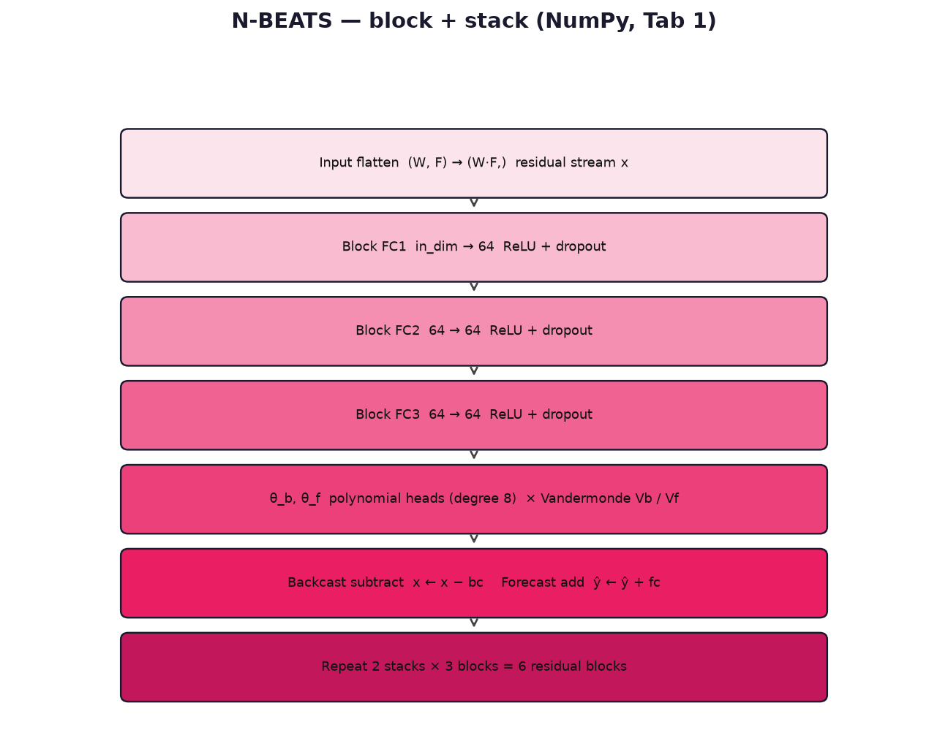

4.1 Layer-by-layer (one block)
Stage | What happens | Shapes / params
Input | Flatten window | (W·F,); in_dim = lookback * n_features
FC1–FC3 | Hidden 64, ReLU, dropout 0.2 each | W1 (in,64), W2/W3 (64,64)
θ heads | Linear to theta_dim=8 (backcast & forecast) | Wtb, Wtf (64, 8)
Basis | Vandermonde Vb on [-1,0], Vf on [0,1] | bc = θ_b V_bᵀ; fc = θ_f V_fᵀ
Residual | x ← x − backcast; ŷ ← ŷ + forecast | 6 blocks (2×3)
Output | Sum of block forecasts | (H,)

4.2 Additional features unique to N-BEATS
- Doubly residual topology: backcast cleans the residual stream; forecasts accumulate (feature fusion across blocks).
- Polynomial (not Fourier) basis — trend-like expansion on a normalised time grid.
- Training updates only forecast heads Wtf/btf via sparse numerical gradients (40 elements/step); other weights stay at init (random features + residual structure).
- HP grid: lr ∈ {5e-3, 1e-3}, epochs ∈ {50, 80} on fold-1 windows when tuning is on.
- Default constructor epochs=100; runner uses grid / locked params.

4.3 Pseudo-architecture
x = flatten(window) # residual
y = 0
for block in 6_blocks:
h = FC3(Dropout(ReLU(·))) # three layers
bc = (h @ Wtb + btb) @ Vb.T
fc = (h @ Wtf + btf) @ Vf.T
x = x - bc
y = y + fc
return y

4.4 Pipeline / UI integration
Same window fusion as CNN-LSTM. Tab 1 ranking colour #FF6584. Tab 3 univariate reuses the same class with claims-only UNI_FEATURE_COLS (not this document’s multivariate EXOG set).

5. Transformer
Purpose: relate every month in the lookback to every other month through multi-head self-attention, then pool and map to the horizon. Designed as a lightweight encoder (no decoder, no causal mask).
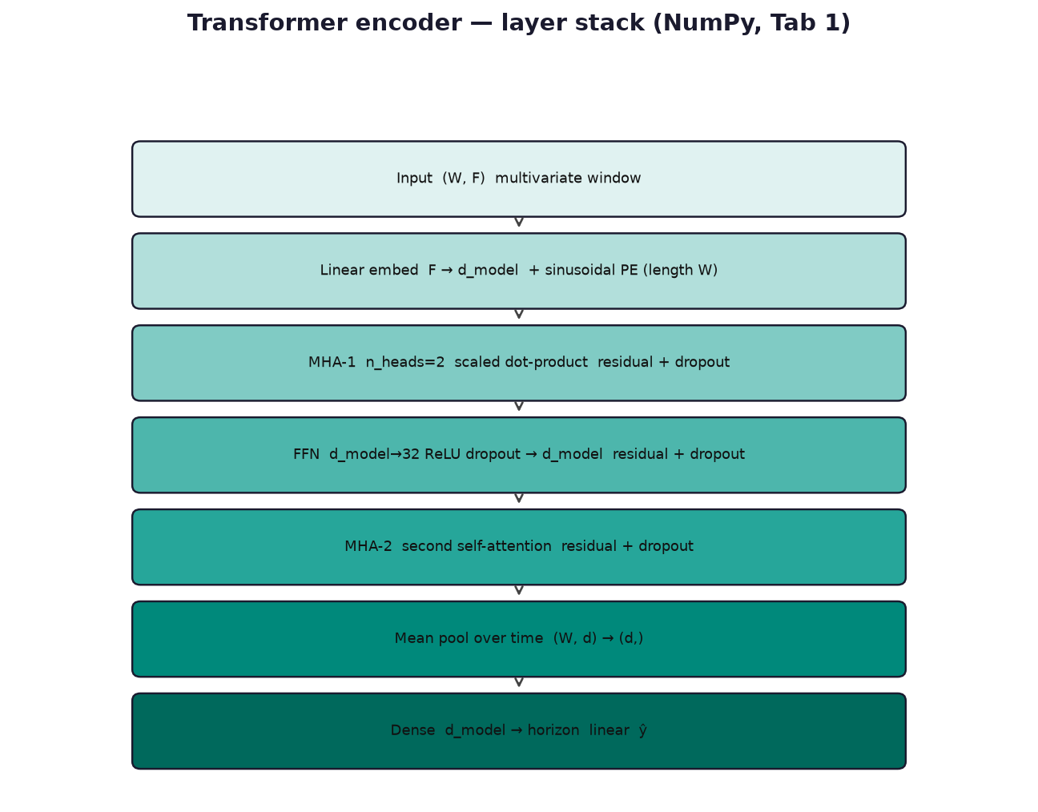

5.1 Layer-by-layer
Stage | What happens | Shapes / params
Input | Multivariate window | (W, F)
Embedding | Linear F→d_model + PE | We (F, d); PE (W, d); d default 16
Attention | Per head Q,K,V; softmax(QKᵀ/√dh); concat; Wo | nh=2, dh=d/2
Residual + dropout | e ← e + Drop(Attn(e)) | (W, d)
FFN | ReLU hidden 32, then d_model, residual + dropout | Wff1 (d,32), Wff2 (32,d)
MHA-2 | Second attention residual (no second FFN) | (W, d)
Pool + Dense | Mean over time; linear to H | Wd (d, H)

Softmax is numerically stabilised by subtracting row max. Attention is encoder-style (full W×W), not causal — the model may attend to all lookback positions equally.

5.2 Additional features unique to Transformer
- Sinusoidal positional encoding (10000 base) added after the input projection — the only explicit time stamp inside the net.
- Pre-norm is not used; residuals wrap attention and FFN (Post-LN-like add).
- HP grid: d_model ∈ {16,32}, lr ∈ {3e-3,1e-3}, epochs ∈ {40,70}; n_heads fixed at 2 in the factory.
- Analytic Dense grads use mean of (xWe+be+PE) — an approximation that ignores attention/FFN for Wd.
- Sparse numerical grads on Wo, Wff2, We (50 elements). Wq/Wk/Wv are not updated (random attention projections).
- d_model must be divisible by n_heads.

5.3 Pseudo-architecture
e = x @ We + be + PE
e = e + Dropout(MHA(e))
e = e + Dropout(Wff2(Dropout(ReLU(e @ Wff1))))
e = e + Dropout(MHA(e))
y = mean(e, axis=time) @ Wd + bd

5.4 Pipeline / UI integration
PE is built for self.W = lookback at init. Lookback W is shortened when the series is short (W = min(12, T − horizon − folds − 2)), so the model is reconstructed per part. Tab 1 / 2 / 5 / 6 same as other DL models.

6. SARIMA (multivariate pipeline baseline)
Purpose: robust seasonal-difference baseline on the claim count series. It does not consume EXOG inside SARIMAX; integration is at ranking, ensemble, and UI.
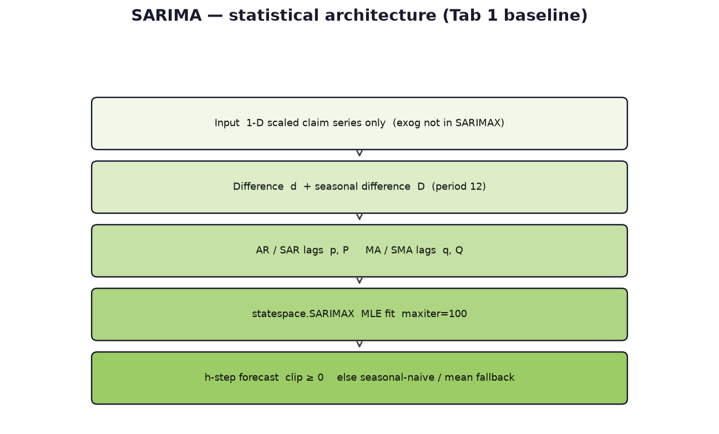

6.1 Layer-by-layer (statistical)
Stage | What happens | Notes
Input | Scaled 1-D claim_count | Same MinMax as DL target
Preprocess | d, D differences inside statespace | enforce_stationarity/invertibility False
ARMA | Non-seasonal (p,d,q) | Grid: (1,1,1), (1,1,0), (0,1,1)
Seasonal | (P,D,Q,s) s=12 | (1,1,0,12) or (0,1,1,12)
Output | forecast(steps=h), clip ≥ 0 | h=1 in CV; h=12 on refit

6.2 Additional features unique to SARIMA
- Fallback if MLE fails: seasonal naive last-12 cycle, else series mean.
- grid_search_sarima minimises 1-step MAE on fold-1 next month (scaled).
- JSON lock converts order tuples via _restore_param_types.
- No dropout / attention / residual nets.

6.3 Pseudo-architecture
try:
m = SARIMAX(y, order=(p,d,q), seasonal_order=(P,D,Q,12))
return clip(m.fit().forecast(H), 0, inf)
except:
return seasonal_naive(y) or mean(y)

7. Inverse-MAE ensemble
Purpose: combine selected multivariate models into a single 12-month path and provide disagreement-based confidence bands. Not a separately trained network.
w_k = (1 / (MAE_k + 1e-9)) / sum_j (1 / (MAE_j + 1e-9))
y_ens_scaled = sum_k w_k * y_k_scaled
y_ens = inverse_minmax(y_ens_scaled) * cm_mults
If the user selects one model, weights collapse to 1.0 on that model and ensemble_raw equals the best (only) forecast. Integration: result['ensemble_raw'], forecast table columns, overlay on Tab 1 plot, pickle bundle['weights'].

8. Keras-CNN-LSTM (Tab 5 only)
Purpose: optional TensorFlow path for the annotated last-6-month evaluation with a different, smaller feature set. Disabled when TensorFlow is not installed (typical on Python 3.14). Not used for the Tab 1 12-month production forecast.
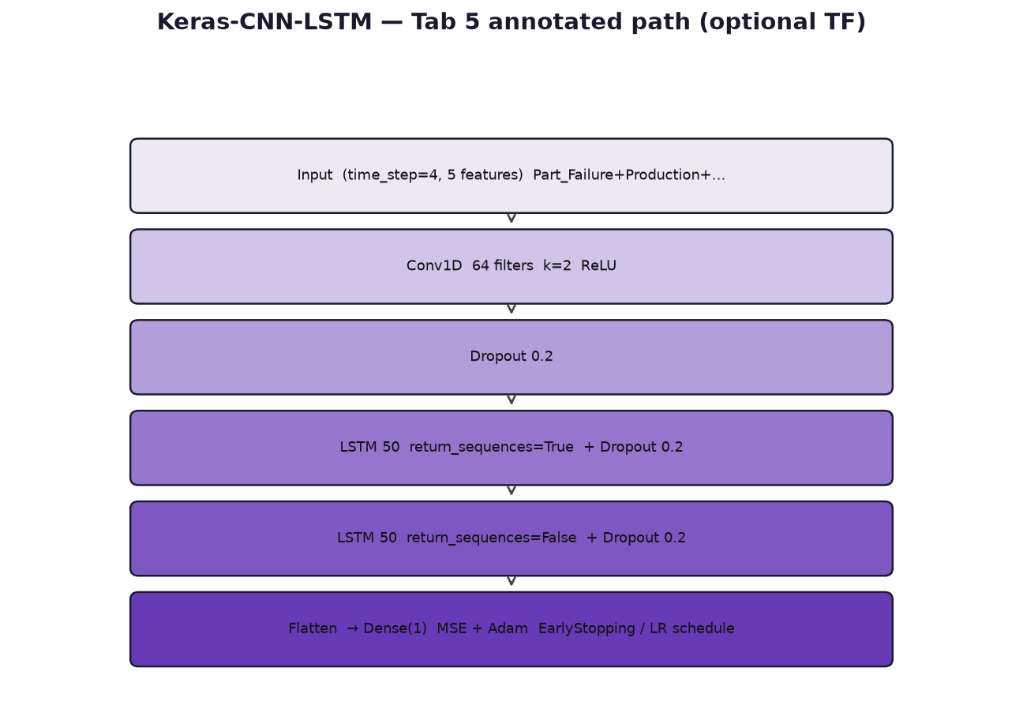
Stage | Detail
Input features | Part_Failure, Production, Warranty_Days, Countermeasure, FCOK_Jan_Aug
Window | time_step=4, target = next Part_Failure
Conv1D | 64 filters, kernel 2, ReLU
LSTM stack | 50 units sequences True, then 50 units last state
Regularization | Dropout 0.2 × 3; EarlyStopping; LR scheduler
Output | Dense(1); inverse scale with zero-padded extra channels

9. Tab-wise UI outputs (what each tab means)
Tab | Name | What it shows for multivariate models | How to read it
1 | Upload & Forecast | Upload, part, model multi-select, production/cost, CM prompts, status (best model), history+forecast plot, 12-mo table, actual vs predicted, ranking, hyperparameters, CPV/claim-ratio history | Green load = schema OK. Ranking is leak-free OOS. Forecast table is the selected/best model after CM. Production must be positive every month to train.
2 | Diagnostics | Production, vehicle age, odometer, FCO/K×process heatmap, rolling CV MAE by fold, model comparison bars | Heatmap = which manufacturing months drive process-month claims. CV plot = stability. Comparison = RMSE/MAE etc. aligned with ranking.
3 | Univariate Analysis | Claims-only Holt-Winters/SARIMA/DL — not the Tab 1 EXOG fusion | Do not treat Tab 3 metrics as multivariate scores.
4 | Reduction | FCO/K month picker, reduction %, original vs adjusted forecast, monthly/cumulative reduction, share, CSV | What-if on peak batches over 36-month warranty. Slider ~55% sensitivity floor in UI copy. Requires a Tab 1 train first.
5 | Annotated Walk-Forward | Last 6 months actual vs forecast, Error, Error%, Accuracy% per model; Keras optional; annotated CSV | Stress-test feeding. Accuracy% is 1-|e|/actual when actual≠0. Run one model first (slow).
6 | Summary & Export | KPI HTML, summary table, global ranking, forecast/ranking CSV, PPTX | PPT includes ranking, economics, CM, optional univariate if Tab 3 was run. kaleido for chart images.

9.1 Tab 1 widgets mapped to models
- Models for forecasting checkbox → selected_models → runner._resolve_selected_models.
- Tune hyperparameters → HP_TUNE path; else locked outputs/best_params.json.
- 12-Month Forecast plot → best_forecast + ensemble/CI when multiple models.
- Actual vs Predicted → oos_actual vs oos_preds[model] for each fold month.
- Hyperparameters Used → best_params including SARIMA tuples and DL lr/epochs/d_model.

10. Edge-case testing notes
Case | Expected behaviour | Where to verify
Empty / unknown part | No monthly rows; train skipped | Tab 1 status
Zero total claims | run_pipeline_for_part returns None, SKIP | Log / status
Series too short (W<4) | SKIP — cannot fit lookback + 6 folds + horizon | Tab 1
Missing production / zeros | ValueError — synthetic production disabled | Tab 1 table
Missing EXOG columns | use_cols intersection; nan_to_num 0 | result['exog_cols']
All-zero OOS actuals | MAPE NaN (safe_mape); R² 0 if variance 0 | Ranking table
SARIMA MLE fail | Seasonal naive or mean | Forecast still ≥ 0
DL fold crash | Pred set to actual; MAE 1.0 scaled — ranking distorted | Tab 2 CV; logs
Single model selected | That model is 'best'; ensemble weight 1; CI from residual scale | Tab 1 plot band
HP tune off + no lock file | Defaults / empty SARIMA dict → (1,1,1)×(1,1,0,12) | HP table
Transformer d_model=32 | n_heads still 2; dh=16 | HP table
Lookback ≠ 12 | CNN valid conv still k=3; Transformer PE resized at init | Artifacts lookback
CM with no FCO/K months (Tab 4) | Warning: select months | Tab 4
Tab 5 without Tab 1 load | Status: load data & select part | Tab 5
No TensorFlow | Keras-CNN-LSTM hidden from checkbox | Tab 5 choices
Inverse scale clip [0,1] | Scaled forecasts outside [0,1] are clipped — extreme DL outputs saturates | Compare scaled vs raw
Parallel HP / fold threads | Non-deterministic completion order; seed still set | Re-runs may differ slightly
Tab 3 vs Tab 1 | Different features and often different winners | Do not mix rankings

11. Recommended edge-case test checklist
- Happy path: upload template claims + production, all four models, tune on, 12-mo table length = 12, ranking has 4 rows, CI band present.
- CNN-LSTM only: ranking 1 row, no multi-model std CI, HP shows lr=0.01 epochs=40.
- SARIMA only: no DL pickle keys required; forecast still plots.
- Short history (~18 months): either SKIP or reduced W; document the message.
- Zero-claim months in the middle: lags filled with mean; heatmap still renders.
- Tab 4: one FCO/K month at 0% ≈ original; 100% reduces only that batch’s share, not the entire forecast to zero.
- Tab 5: six test months, Accuracy% blank/NaN when actual is 0.
- Export: PPT builds after Tab 1; fails clearly if python-pptx missing.
- Lock file: second train with tune off reuses JSON; SARIMA orders remain tuples after reload.

12. File map
Path | Role
forecasting/models/base.py | ReLU/sigmoid/tanh, dropout, early stop, Adam
forecasting/models/cnn_lstm.py | CNN-LSTM
forecasting/models/nbeats.py | N-BEATS blocks
forecasting/models/transformer.py | Transformer encoder
forecasting/models/ml_models.py | SARIMA + HP_GRIDS
forecasting/pipeline/runner.py | Windows, CV, rank, ensemble, persist
forecasting/pipeline/annotated_forecast.py | Tab 5 Keras + NumPy
forecasting/data/loader.py | EXOG, monthly, FCO/K CM
forecasting/metrics.py | RMSE/MAE/MAPE/R² rank
forecasting/dashboard/app_ui.py | Gradio tabs 1–6
forecasting/config.py | MODEL_NAMES, seeds, weights

