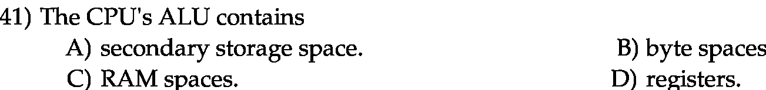
Answer:
d

Explanation:

ALU: It is used to perform logica and arithmetic operations.It is the important component of the CPU.
ALU consist of registers. It loads data from the register(space available in the CPU) to perform various arithmetic calculations.

