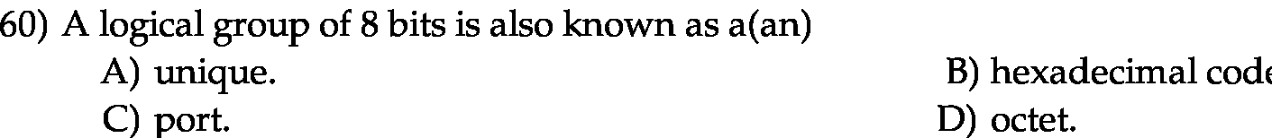
Answer:

d

Explanation:

Octet in computer science is the unit of information stored digitally. Octet simply means 8 bits but it is really used now a days, as the most frequently used term is byte. Each byte contains 8 bits.

