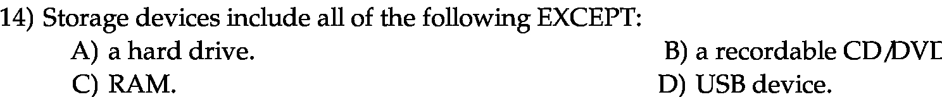

Answer:

c

Explanantion:

RAM is the volatile memory. It holds data till the computer is power on. After the computer is switched off it loses the data. Rest of the devices contains the data, permanently.

