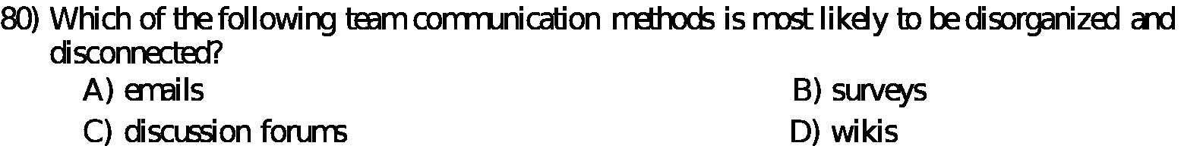
Answer:

a)

Explanation:

Emails are likely to go away as they are getting replaced by discussion forums. Discussion forums are more prodctive and increase the productivity much better than the emails. Also they are organzied and better planned.

