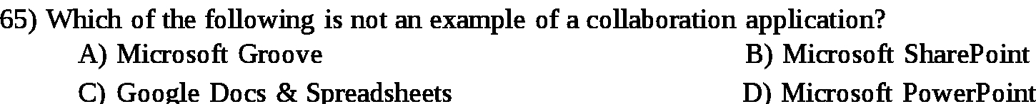
Answer:

a

Explanation:

Collaboration application are the applicatons in which the people can work collectively. All ofthe given softwares are collaborative as, everyone can work on them together except Microsoft Groover which is a music listening portal.

