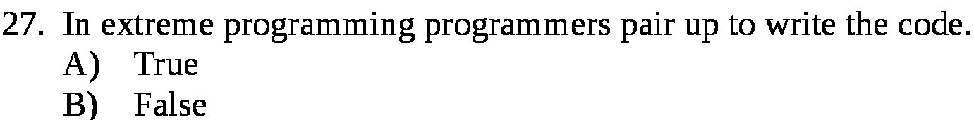
Answer:

a

Explanation:

When the programmers pair up to code together, this is called the pair programming. The main motive of this is to make everyone aware what everyone else is doing. This also increases the wirder communication.

