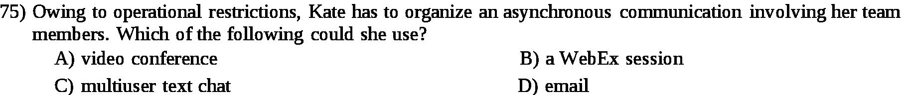
Answer:

d

Explanation:

Asynchronous communication is used when you want to send the information at the regual intervals of time. So, if the kate want to arrange such meeting the best way for her is email.

