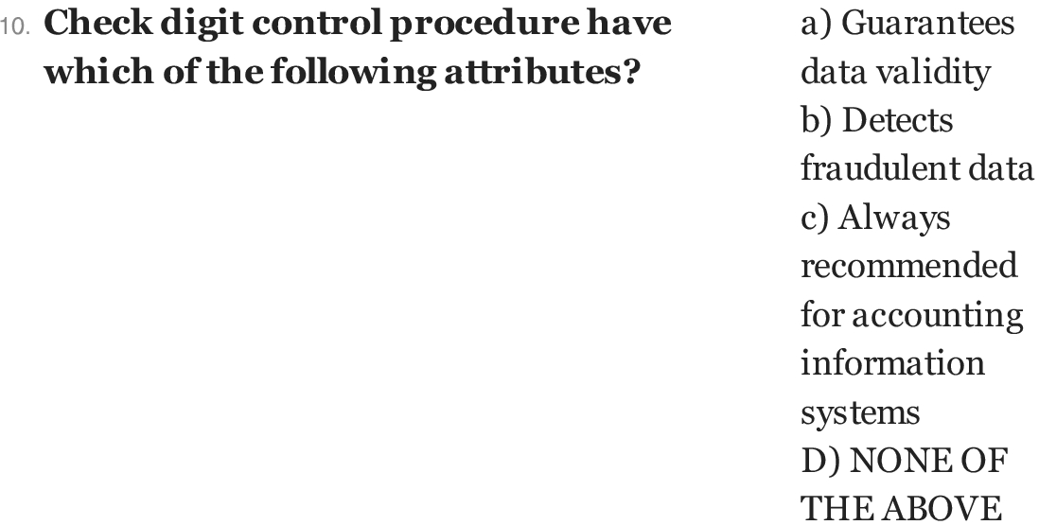

Answer:

d

Explanation:

check digit control is used to check the redundancy, errors in the database. This might have come up while entering the data manually in the database. For eg. Bank acccount number.

