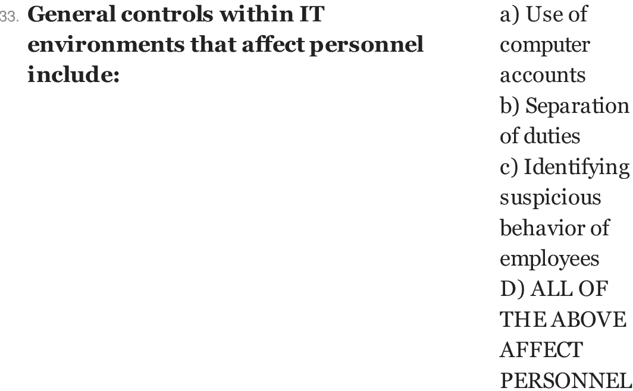

Answer:
d

Explanation:

Using computer accounts and identifying or getting infromal data about he employee are the vital part of the general control. All these affect the growth of the personnel directly or indirectly.

:

