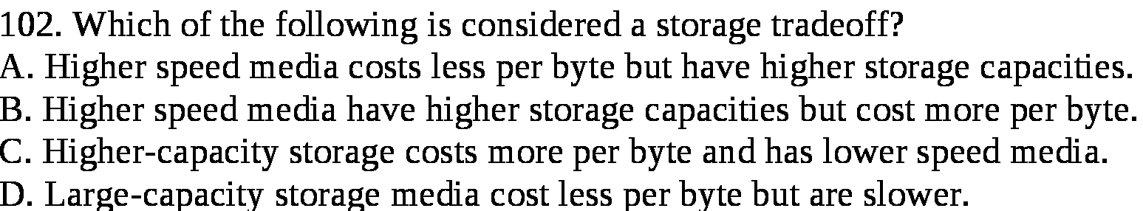

Answer:

d

Explanation:

Storage tradeoff says that the high speed storage device are costly but the storage provides is less. On the contrary, low speed storage devices have large storage capacity but are slower in nature.

