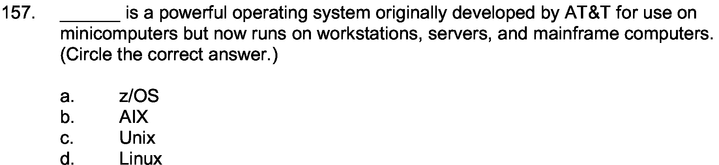
Answer:

c

Explanation:

Unix is a powerful oprating system which was made in the 1970s. The maker of this include Dennis Ritchie and colleagues. It was made for programmers, most specifically.

