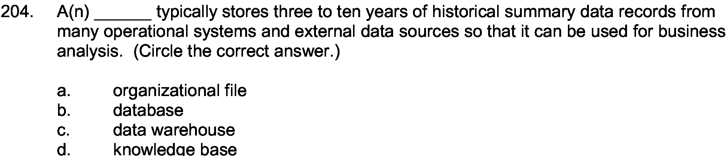
Answer:

c

Explanation:

https://www.coursehero.com/qa/wait/12114819/

