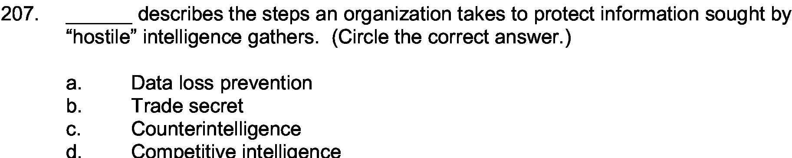

Answer:

c

Explanation:

Counterintelligence is protecting one intelligence agency from opposition agency. This is done so that any assassination or other threatening attack can be avoided.

