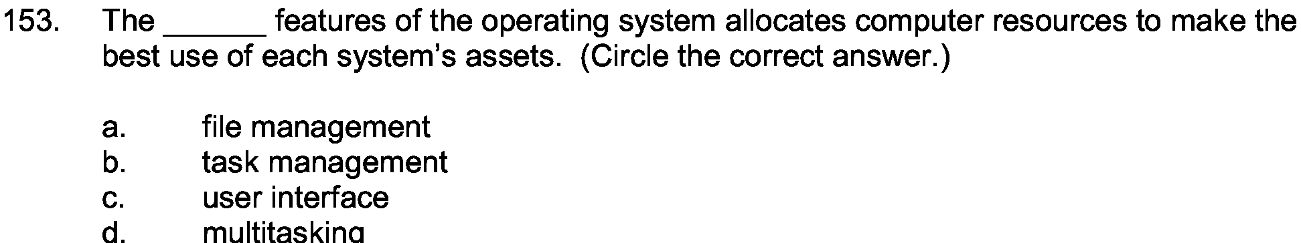
Answer:

b

Explanantion:

Task manager contains all the list of the recent processes and their life cycle. With the help of this you can keep a track of all the processes and find out that whch software or the process is taking more time and space.

