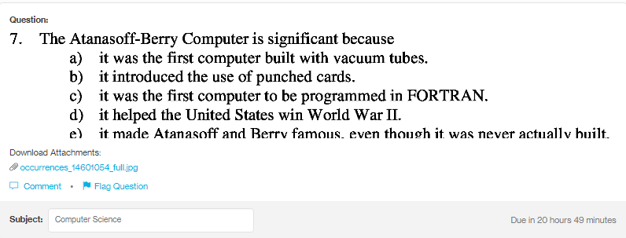
Answer:b d
Explanation:
The Atanasoff-Berry Computer was first electronic computer. It was popularly know ABC. It was neither turing complete nor programmable. Due to the digital prowess, it efficiently introduced the use of punched cards, and was also used efficetivelly in world war II.

