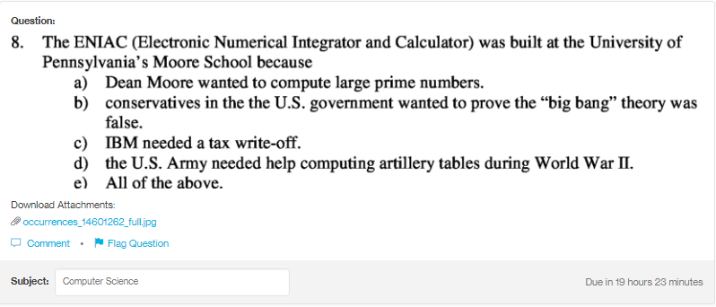
Answer:
d

Explanation:
The primary reason for the development of ENIAC was to help the US army in finding hte aritillery firing tables. It was completed in the year 1945 and put to the work at the end of the year.

