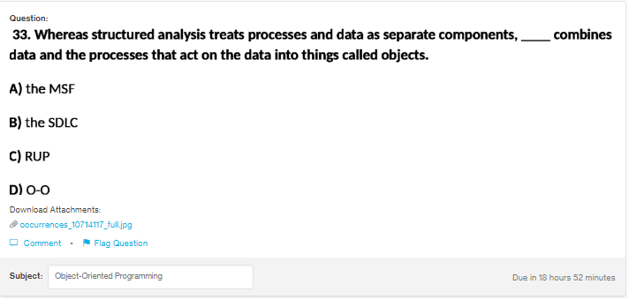
Answer:d
Explanation:
Object oriented programming works on the objects and classes. In O-O every real world thing can be represented int he form of objects. So, o-o has processes and data which are encapsulated in the class and works on objects.

