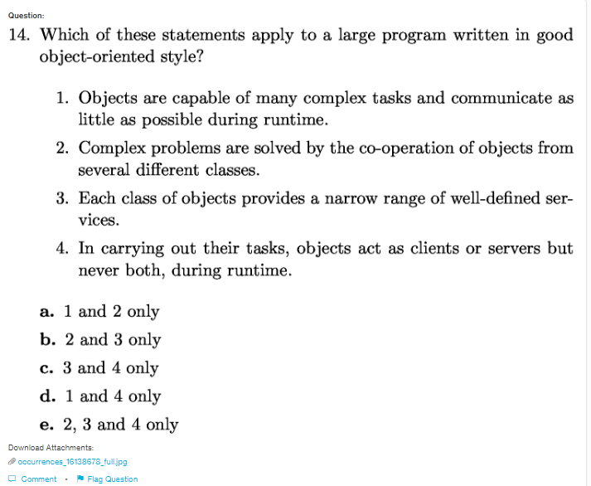
Answer:e

Explanation:
The advantage of writing the large program in OOP style is to increase the reusability of the code, make code easier to understand and debuggable as well. Complex problem need team work hence people can work on various modules separately. Each class has modules which can be reused.

