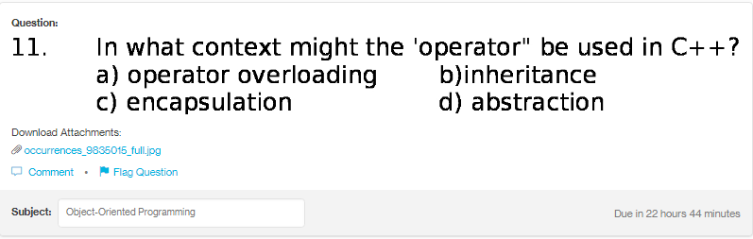
Answer:
a
Explanation:
In the c++, the operator is used for the operator overloading purpose. The meaning of operator overloading is to provide the additional functionality to the operators.

