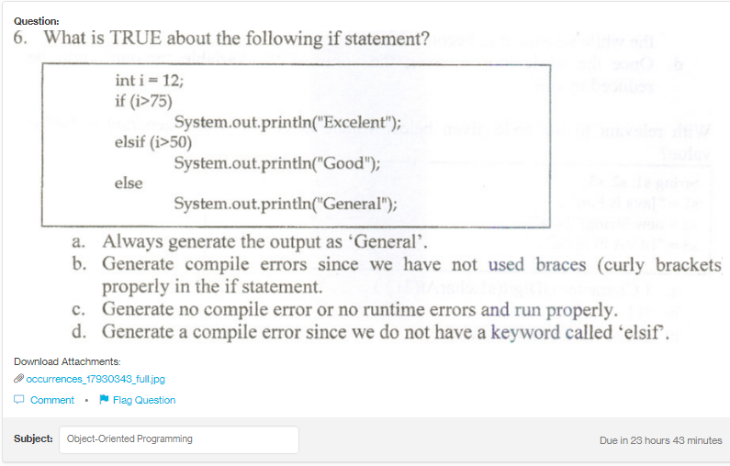
Answer:
A

Explanation:
It will always generate the output as “General” as none of the condition is getting satisfied, so it will always execute the else block.

