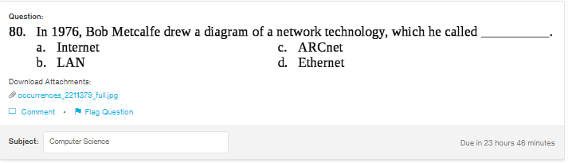
Answer:
d

Explanation:
Bob Metcalfe was the first to provide the logical representation of the Ethernet connection in 1970s. Ethernet is basically a medium of transmission of information.

