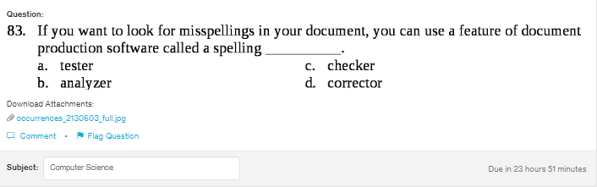
Answer:c

Explanation:
In software technology, a checker is a program which can be used to check any spelling mistake in the document. It it founds any spelling mistake, it just underlines that word.

