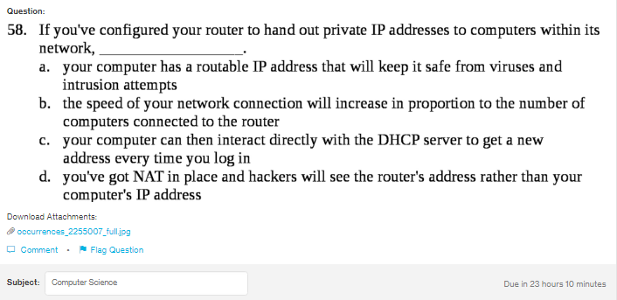
Answer:
d

Explanation:
One can still use the private IP address on the private computer, if the netowrk is using the NAT (Network address translation). For this the router or the other device should be between the network and the itnernet.

