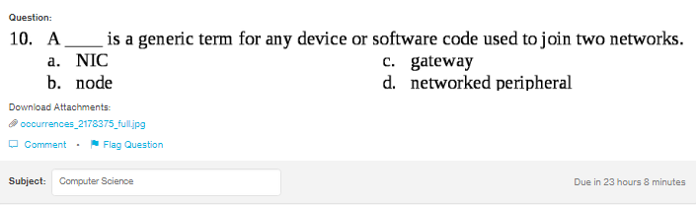
Answer:
c b

Explanation:
Gateway and node is the general term which is used to join two networks. Gateway maintains the flow of the data from one network to another network.

