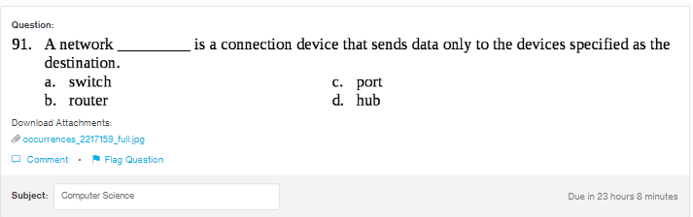
Answer:
a

Explanation:
A network switch uses packet switching to send, process and receive data tat the destinattion or the receiver’s end. Switches which are used for the Ethernets are most common networking devices.

