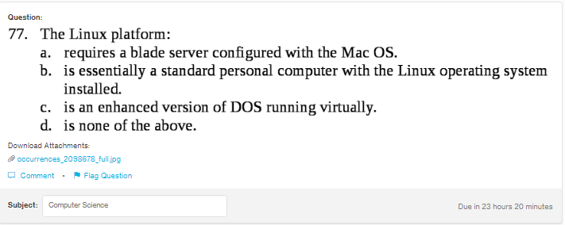
Answer:

d

Explanation:

Linux OS is a freely availabe operating system which can be easily installed on computers, personal computers, mobile devices and others.

