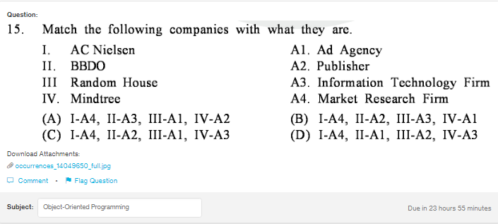
Answer:
d

Explanation:
AC Nielsen is a Market Research company based in USA, BBDO is a Ad company also based in USA, Random House is also a US based company with focus on book publishing and Mindtree is an Indian IT and outsorucing company based in Bangluru.

