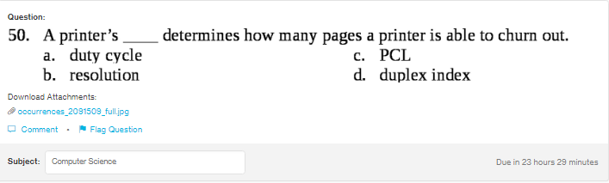
Answer:
a

Explanation:
Duty cycle is the period in which a system or the signal is active. In case of printer, it tells how may pages the printer will be able to print out.

