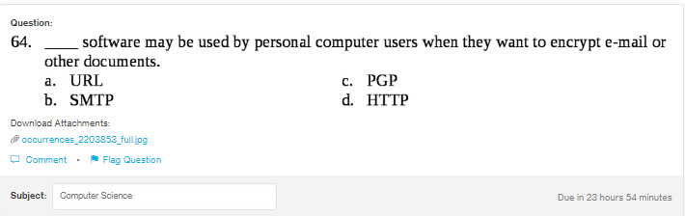
Answer:
c
Explanation:
PGP, Pretty Good Privacy is a program which is used to encrypt emails, files and documents. It icreases security of the email communication.

