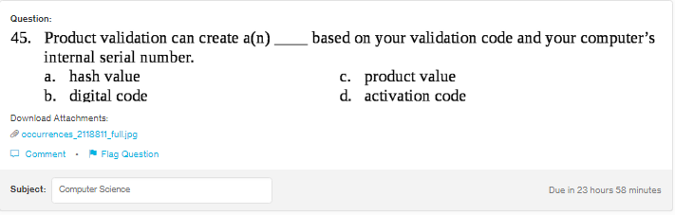
Answer:
a
Explanation:
Hash is used to check, if the file is not corrupt. A hash is an algorithm which generally cosnist of the fixed length, irrespective of the length of the input.

