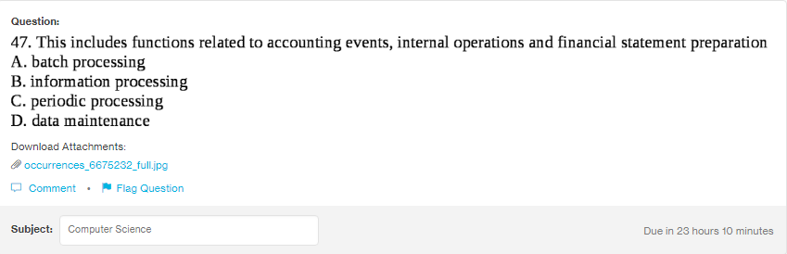
Answer:
b

Explanation:
Information processing in computer science is known as the manipulation of digital data by any electoronic devices or computers. So, has functions related to the finance, account and wherever enough data is given.

