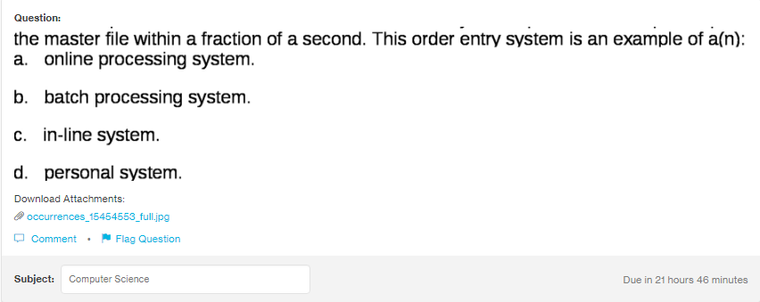
Answer:
a

Explanation:
When the system updates the master file as soon as, receipt number or the order number is entered in the database, this is an example of online processing system. No matter whereever the perosn is around the globe, the updation takes place in the fractions of second.

