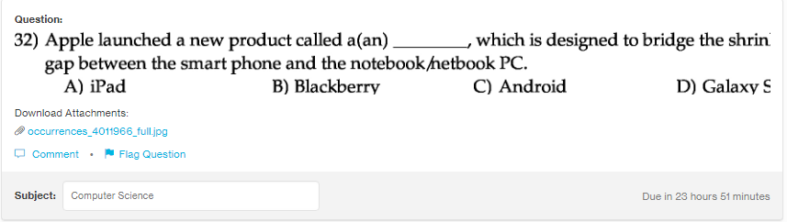
Answer:
a

Explanation:
iPad are the tablet computers which are made by the Apple Inc. The iPad are almost similar to the Pcs, they have added advantages like you can connect external keyboard or can connect many other gadgets through the bluetooth. With the advent of iPad touch based market grew heavily.

