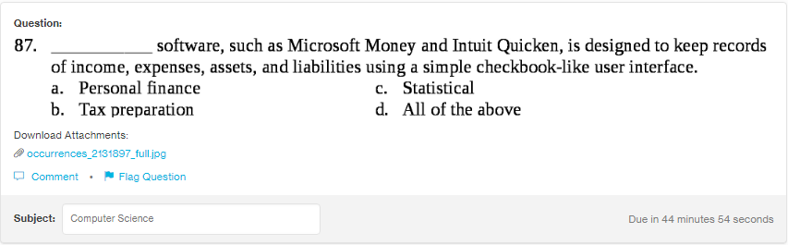
Answer:
d

Explanation:
All these softwares are used for various important purposes such as finance is used for managing your daily expenses, statistical is used for budget maintenance and tax preparation is used for maintaining the tax records.

