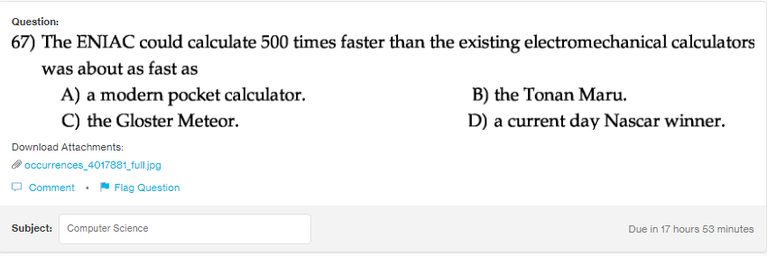
Answer:
a

Explanation:
The speed of the ENIAC was comparatively very hgh than the old electromeachanical calculators. It was about as good as the current calculators.

