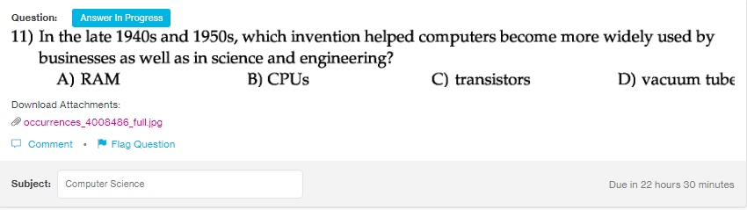
Answer:
c

Explanation:
The first generation computers are very large, heavy and bulky, and not reliable also. With the coming of transistor computer which uses discrete trnasistors in place of vacuum tube, made the computer easily accessible to the large number of people in 1940s and 1960s.

