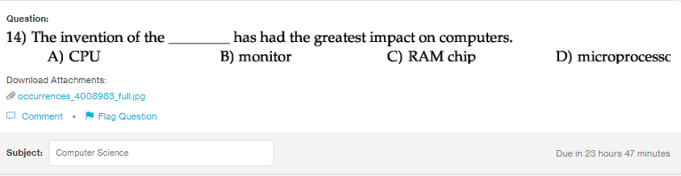
Answer:
d

Explanation:
Microprocessors are computer procesors which contain CPU on the single IC or in few Ics. It is a multipurpose device and most important part of the computer.

