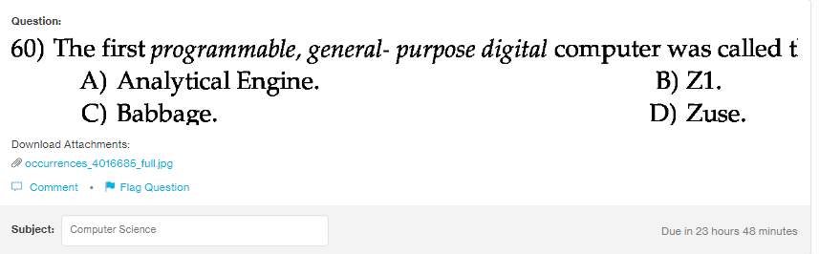
Answer:
b

Explanation:
z1 was the first computer which was programmable and digital. It used the boolean logic and floating point numbers too but was unreliable in operations.

