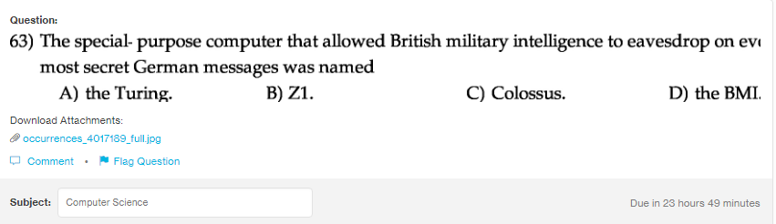
Answer:
c

Explanation:
Colossus was the collection of computers whcih were made by British codebrakers. It was used to decrypth the messages sent between the German Army and their authority.

