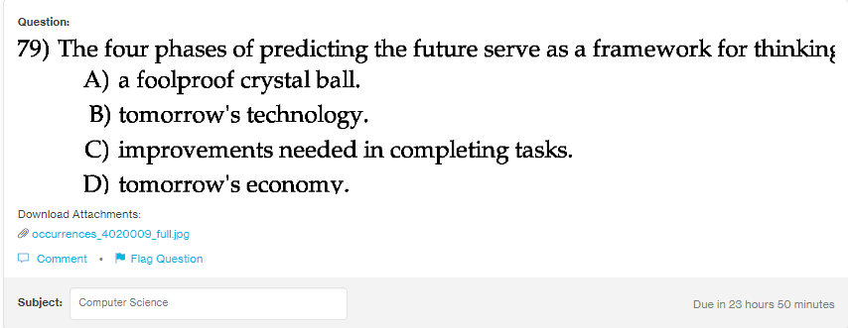
Answer:
b

Explanation:
While planning a software during the phase development cycle, it is check whether it can be compatible with the coming technology in the market, somewhere in the future. This is important for the long term compatibility of the system.

