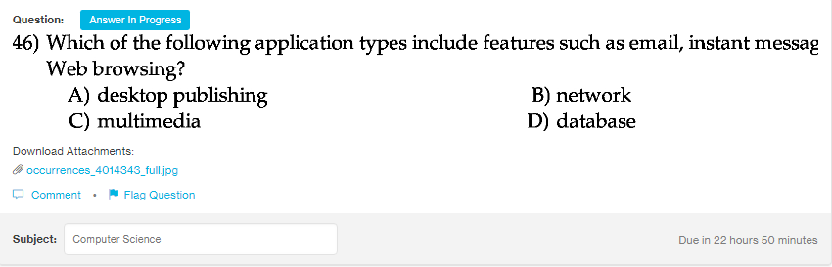
Answer:b

Explanantion:
Network is used for sending emails, doing instant messaging through applications like gmail and yahoo and also for browsing. All the tasks relate to internet are done by the network easily.

