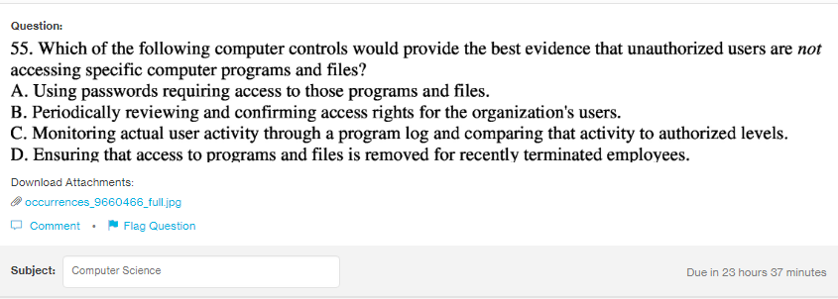
Answer:
b

Explanantion:
To protect the specific programs and files from the unauthorized people, the best way is to check the access right to the people of the organization. These access right should be checked at certain period of interval.

