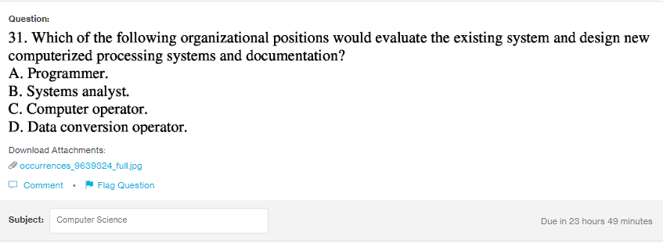
Answer:
b

Explanation:
The task of the system analysts is to evaluate the design and implementation of the infomation system. He or she analyses the IS and directs the programmers to fulfill the task accoding to the client need.

